Instant Recipes
Instant recipes are ideal for people with a hectic lifestyle. These help people grab a delicious treat for themselves or for family in no time. These can work wonders when guests turn up without ultimatum. Charm people with these simple instant, delicious recipes!

If you wonder what you need to cook every day, then this book presents to you 50 instant recipes that can offer you more power in the kitchen while you are hungry and tired. Home cooked meals have a plethora of benefits to offer. This book offers you the power to bring in the element of change in your menu. Follow the simple recipes and let only healthier and hygienic meal make it to your plate.

Making dishes require planning. However, all you need are ingredients when you want to craft these simple, instant recipes. Stock your panty with the essential ingredients and you are set to treat yourself to good food every day.

- Tomato Stacks
Are you looking for a healthy starter option? If yes, then tomato stacks are just for you. This can be prepared in less than five minutes.
Ingredients
- Tomatoes
- Fresh Mozzarella
- Basil Leaves
- Seasoning [Salt and Pepper]
Procedure
- Slice fresh tomatoes and mozzarella.
- Layer whole basil leaves and mozzarella between tomato slices.
- Season with pepper and salt.

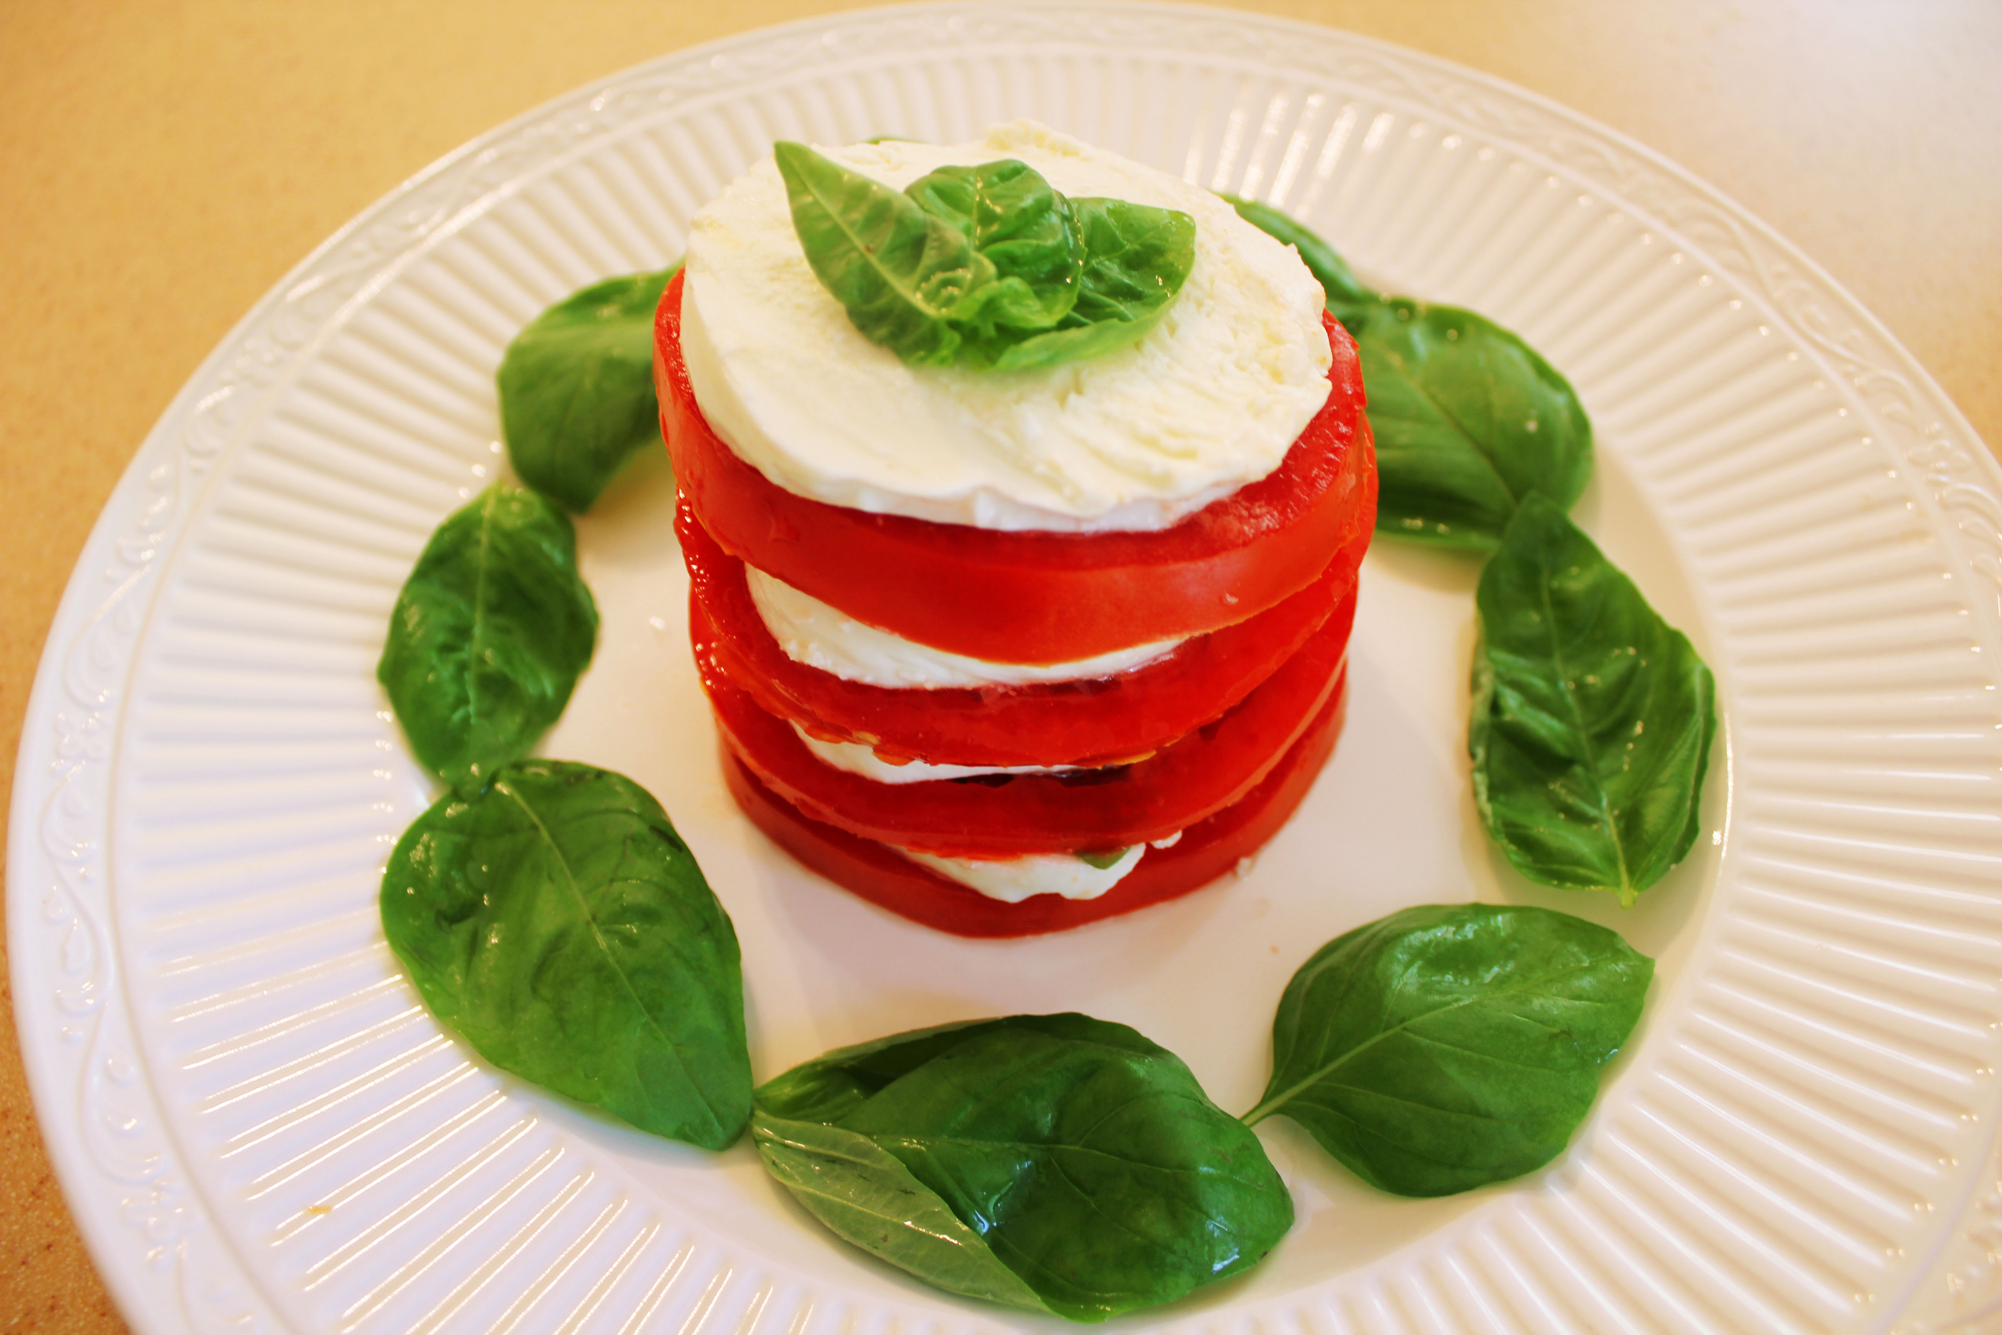

- Cheesy Pitas
Imagine cheese melting in your mouth after a warm day at work! Sounds heavenly; doesn’t it? These cheesy pitas are easy to prepare. You do not have to be an expert in kitchen for crafting these.
Ingredients
- Pocket Pitas
- Asiago Cheese
- Sliced scallions
Procedure
- Stuff the halved pocket pitas with sliced scallions and asiago cheese.
- Heat in a toaster oven till the cheese melts entirely.
- Slice into the wedges and you are ready to gorge on this delicious treat.
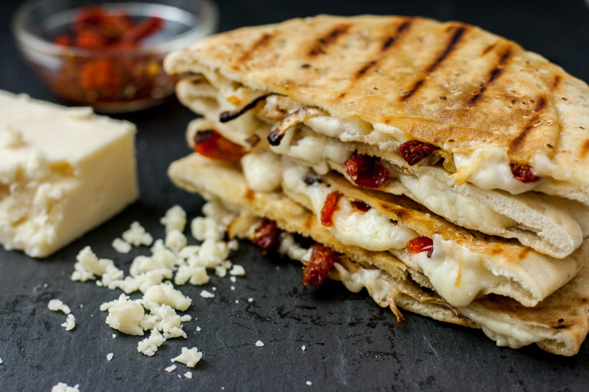

- Taco Dip
Dips add extra flavors to the bag of potato or tortilla chips that you picked from the store. Indulge in this dip as it melts into the mouth and can be prepared in less than five minutes.
Ingredients
- Softened Cream Cheese
- Shredded lettuce
- Chopped tomatoes
- Shredded Cheddar Cheese
- Taco seasoning
Procedure
- Season the softened cream cheese lightly with taco seasoning.
- Top with chopped tomatoes, shredded cheddar cheese and shredded lettuce.
- Serve with tortilla chips.

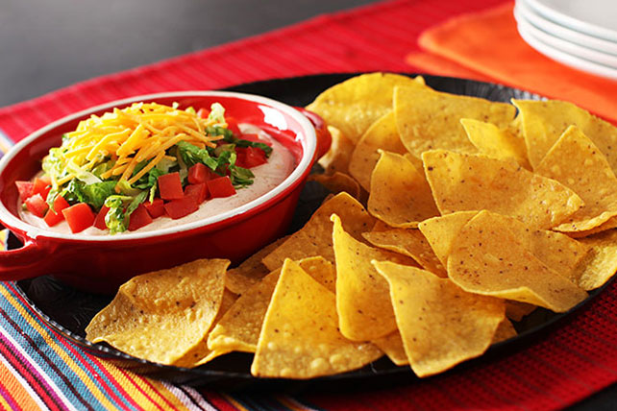
- Tomato Soup Shots
A tomato soup shot is a cool way of making people indulge in the same old tomato soup. This can be done to impress your guests or while you are hosting a mini party for your friends.
Ingredients
- Instant tomato soup
- Melba toast
- Brie cheese
Procedure
- Prepare instant tomato soup.
- Divide the soup prepared among shot glasses.
- Serve with brie cheese and Melba toast.

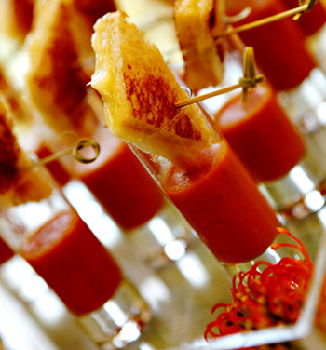
- Parmesan Chips
Are you bored of snacking on chips? Here is a wonderful way to transform them into cheesy delights.
Ingredients
- Grated Parmesan Cheese
- Chips [Potato/Zucchini]
Procedure
- Take a nonstick baking sheet and spread few tablespoons of grated parmesan cheese on it
- Place potato or Zucchini wafers on it.
- Place them about an inch apart.
- Bake until they turn golden brown at 350° for six to eight minutes.

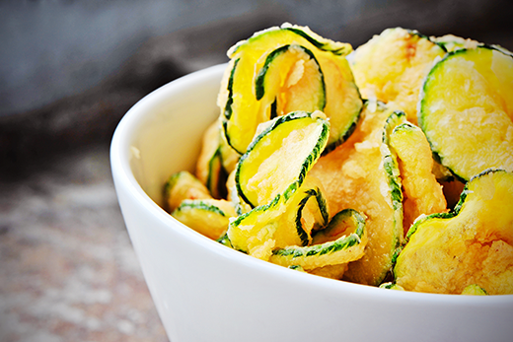

- Salad-on-a-Stick
Not everybody is fond of salad. However, here is a fun way of making people indulge in them. A salad-on-a-stick would certainly grab the attention of everybody.
Ingredients
- Cucumber
- Black olives
- Green peppers
- Cherry tomatoes
- Feta cheese cubes
Procedure
- Skewer black olives, cherry tomatoes, feta cheese cubes, chopped green peppers and cucumber square.
- Drizzle with vinaigrette.
- Decorate on a stick if you are hosting a party.

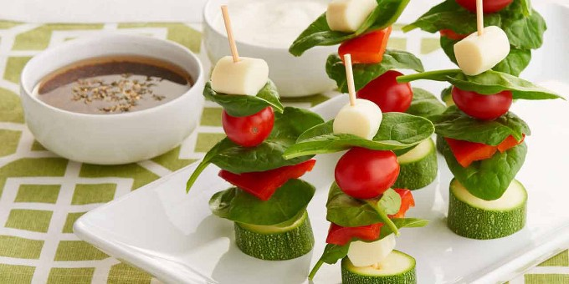

- Salami Rolls
Planning for something unique to appeal to your taste buds? Here is a quick, delicious and easy recipe for you to gorge on.
Ingredients
- Senoa salami
- Cream cheese
- Olives
Procedure
- Spread a layer of cream cheese on sopressata or genoa salami.
- Roll it and secure with a tooth pick.
- You can consider threading pitted olive through the tooth pick.
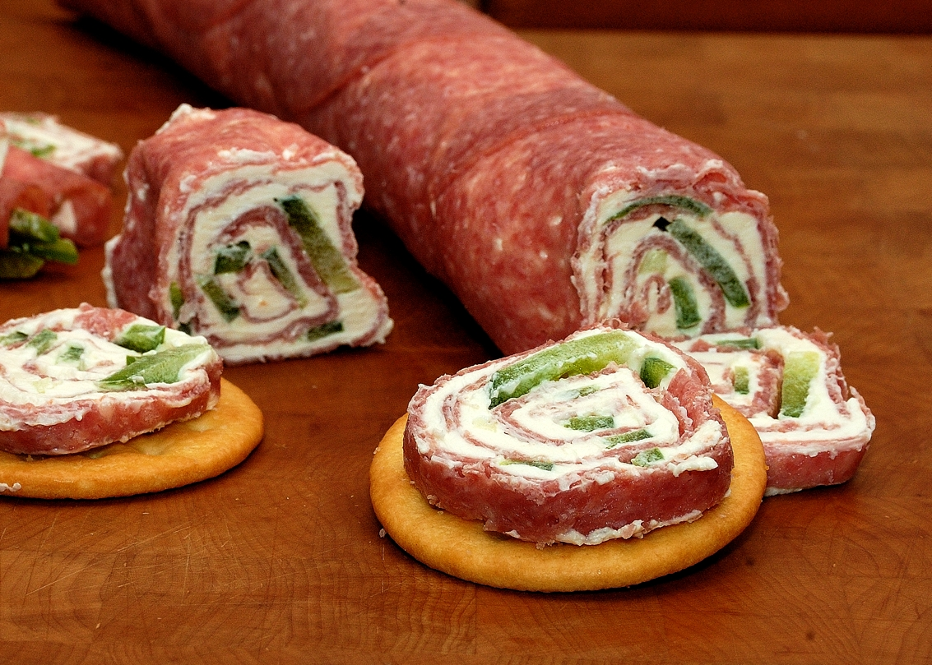

- Seven-Layer Hot Dog Dip
Who doesn’t love gorging on hot dogs? Here is a quick recipe for seven-layer hot dog that can be prepared quickly to appease your grumbling stomach.
Ingredients
- Chopped hot dogs
- Warmed baked beans
- Shredded cabbage
- Chopped tomatoes
- Ketchup
Procedure
- Layer chopped hot dogs, warmed baked beans, chopped tomatoes, ketchup and chopped tomatoes.
- You can consider using mustard sauce for the flavor.
- Serve with tortilla chips and relish.

- Thai Lettuce Wraps
Do you love wraps? Here is a fun way of making lettuce wraps laden with shrimps. You would love this Thai delicacy!
Ingredients
- Warm shrimp
- Shredded carrot
- Thai peanut sauce
- Boston lettuce leaves
Procedure
- Wrap shredded carrot, Thai peanut sauce and warm shrimp in Boston lettuce leaves
- Secure with toothpicks.
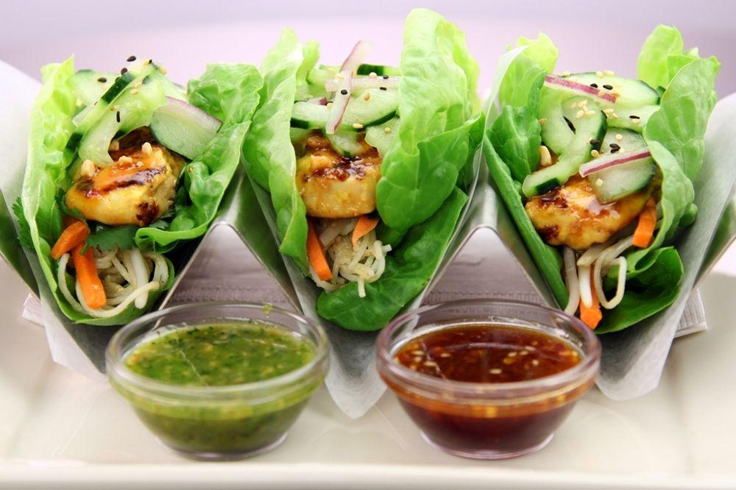

- Mediterranean Cucumber Bites
Do cucumber bites sound boring to you? This recipe would make you think again.
Ingredients
- Cucumber rounds
- Greek yoghurt
- Sun dried tomatoes
- Dried oregano
- Extra-virgin oil
Procedure
- Prepare a mixture of Greek yoghurt, extra virgin oil and dried oregano.
- Top cucumber rounds with this mixture.
- Finally, top with sun dried tomatoes.
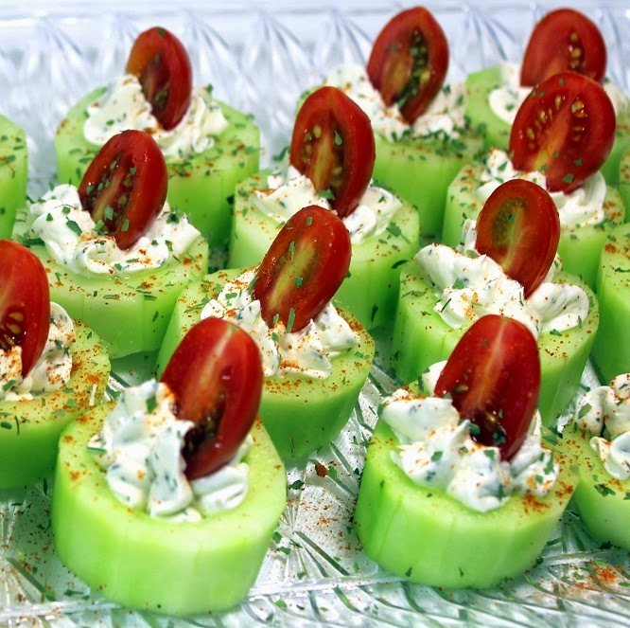

- Chip-and-Dip
Looking for a quick recipe to snack on? Here is a wonderful treat that is a health balance of taste and nutrition.
Ingredients
- Kettle chips
- Hummus
- Sliced radish
- Seasoning
Procedure
- Top kettle chips with hummus.
- Top this with radish that is thinly sliced.
- Consider seasoning with salt and pepper.
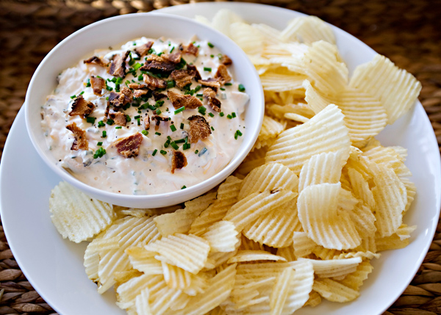

- Stuffed Cherry Tomatoes
This is the best way you can empty cherry tomatoes from your fridge. Not a fan of vegetables? Try this quick recipe and you would want some more.
Ingredients
- White beans
- Chopped shallot
- Chopped parsley
- Extra virgin olive oil
- Cherry tomatoes
Procedure
- Puree a can of white beans.
- Add chopped parsley and chopped shallots to it.
- Stir the mixture in extra-virgin olive oil.
- Pour the mixture into cherry tomatoes.
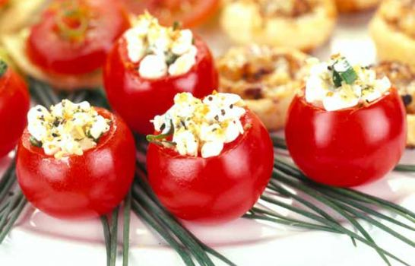

- Endive Boats
This may seem more like a salad and few people would not even want to touch this delicacy. Let yourself not be fooled by appearances. Endive boats are served as snacks at parties. These are not just healthy but delicious too.
Ingredients
- Endive
- Cream cheese
- Chopped tomatoes
- Seasoning
Procedure
- Separate endive into individual leaves.
- Spread softened cream cheese on each leaves.
- Top with chopped tomatoes
- Season with pepper and salt.

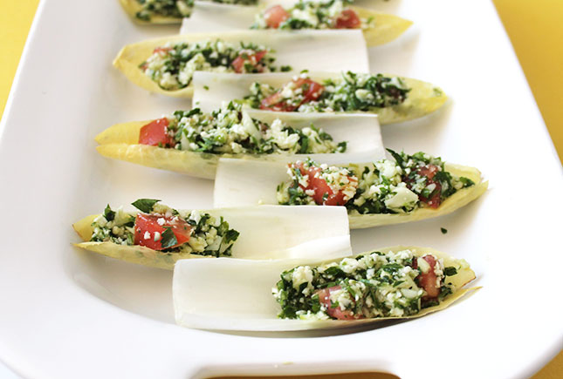
- Cocktail Skewers
If you love shrimps, you will love this recipe. It is easy to craft and imparts rich flavors to old shrimps.
Ingredients
- Frozen, cooked shrimp
- Red bell pepper squares
- Sour cream
- Dill
- Lemon juice
Procedure
- Thaw frozen shrimp.
- Skewer red bell pepper squares and shrimp.
- Mix sour cream, lemon juice and dill.
- Serve the dip with skewers.
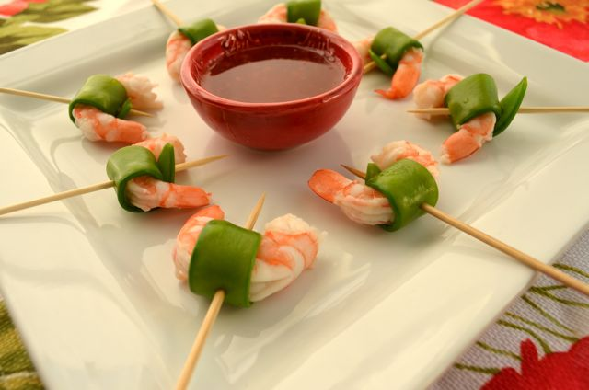

- Shrimp Cocktail Shots
Shrimp cocktail shots? Doesn’t this recipe sound creative? Yes, it is. Try it and you will know how you can transform something really simple into an elegantly crafted dish.
Ingredients
- Cocktail sauce
- Lemon juice
- Cooked shrimp
- Celery stick
Procedure
- Thin cocktail sauce and add lemon juice to it.
- Fill shot glass with this mixture halfway.
- Add shrimp and celery stick to each shot glass.

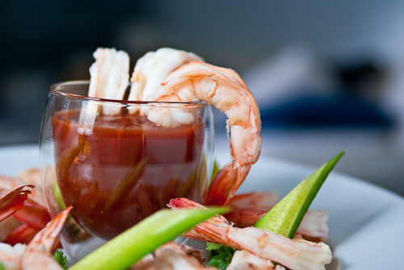

- Pear Party
You can start a party whenever you wish to. This delicious pear treat is something worth indulging in.
Ingredients
- Pears
- Goat cheese
- Honey
- Chopped walnuts
Procedure
- Slice pears lengthwise after core and quartering.
- Spread softened goat cheese on the top.
- Drizzle with honey.
- Garnish with chopped walnuts.
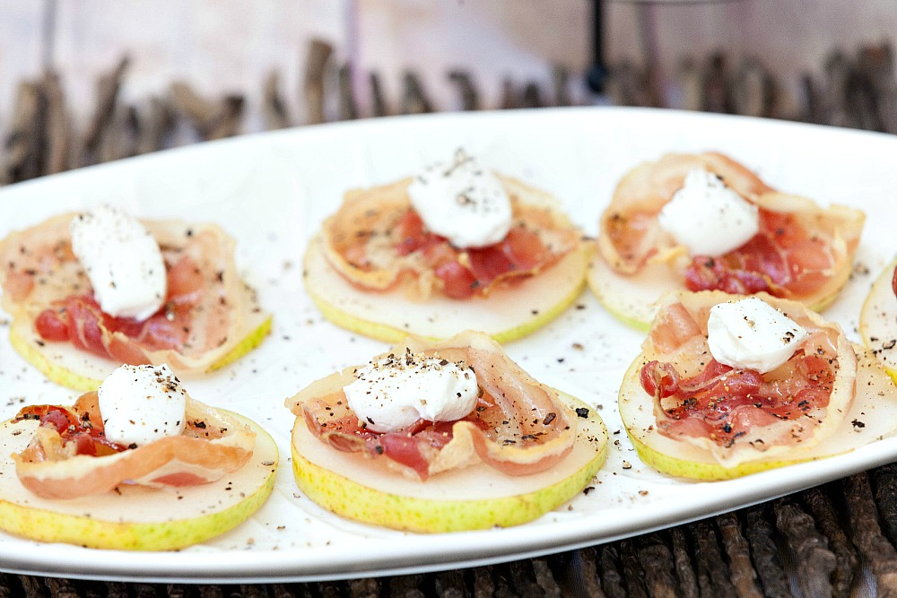

- Tomato-and-Watermelon Bruschetta
Laden with classic Bruschetta and juicy tomatoes make this dish a perfect appetizer.
Ingredients
- Grape tomatoes
- Chopped seedless watermelon
- Basil
- Baguette slices
- Extra-virgin olive oil
Procedure
- Combine chopped seedless watermelon and grape tomatoes.
- Add extra virgin olive oil, salt and basil.
- Layer the mixture of toasted baguette slices.
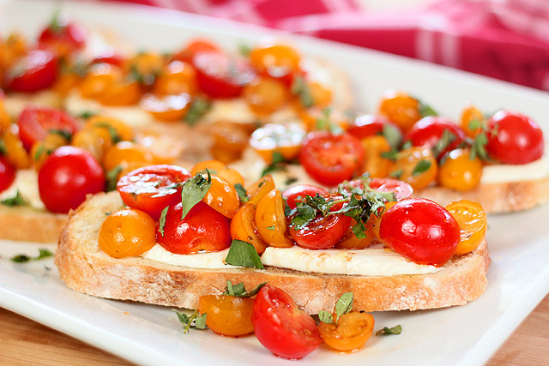

- Waffle Bites
All you need is four ingredients and five minutes to create a mouth-watering dish. Try it yourself if you cannot believe it!
Ingredients
- Frozen mini waffles
- Sour cream
- Chopped mangoes
- Smoked paprika
- Cayenne pepper
Procedure
- Toast frozen mini waffles.
- Top with a sour cream.
- Top this with smoked paprika, chopped mango and cayenne pepper.
.

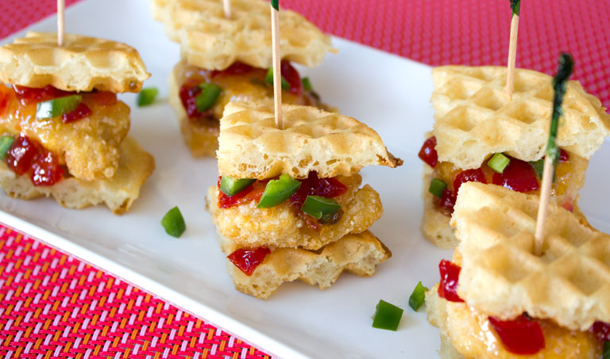

- Strawberry Rolls
Looking to save time in morning? Tempting strawberry rolls can make your breakfast menu seem more tempting. These rolls are fluffy, soft and would melt the flavors in your mouth.
Ingredients
- Tortilla
- Strawberry cream cheese
- Strawberries
- Lime juice
Procedure
- Warm a tortilla.
- Spread softened strawberry cream cheese on the tortilla that you have warmed
- Top this with strawberries that have been thinly sliced and add lime juice.
- Roll tortilla tightly.
- Slice it cross wise and use a toothpick to piece through the roll.

- Open-Faced Honey-Ricotta Cookies
These cookies would invite more people to your house. These are delicious and would satisfy your taste buds instantly.
Ingredients
- Ricotta cheese
- Honey
- Cinnamon
- Vanilla wafers
- Toasted pine nuts
Procedure
- Sweeten ricotta cheese with honey.
- Add cinnamon for flavor.
- Top vanilla wafer with this mixture.
- Layers with toasted pine nuts finally.

- Naughty-and-Nice'wich
Want to spice up your lunchtime? Here is a recipe for crafting tasty and fresh sandwich to deal with hunger pangs during noon.
Ingredients
- Chunky peanut butter
- Toasted white bread
- Bacon
- Banana
- Honey
Procedure
- Spread chunky peanut butter on a piece of toasted white bread.
- Layer the other toast with honey.
- Sandwich with sliced bacon and bananas.
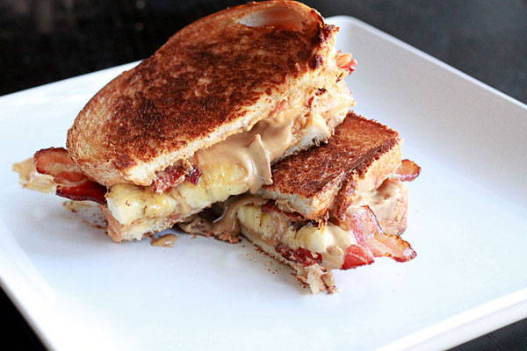

- Ballpark Wrap
Try these easy to make wraps filled with veggies, cream cheese and turkey. This recipe is one of the best ways to make your appetizer tray look alluring.
Ingredients
- Bell pepper
- Red onion
- Cooked sausage
- Tortilla
- American cheese
Procedure
- Toss red onion, cooked sausage, sliced bell pepper with pepper and salt.
- Spread American cheese on flour tortilla.
- Wrap in foil and heat in oven.

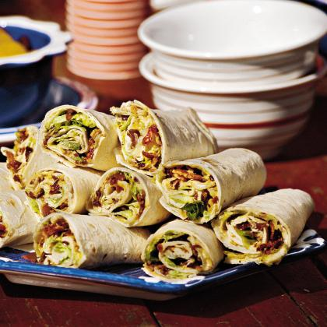
- Hot Wing Sandwich
This spicy rotisserie chicken sandwich will please people who love indulging in spicy delights.
Ingredients
- Rotisserie chicken
- Chopped celery
- Hot sauce
- Sandwich roll
- Blue cheese dressing
Procedure
- Toss pulled rotisserie chicken with hot sauce, salt and chopped celery.
- Spread blue cheese dressing on both sides of a soft sandwich.
- Sandwich the chicken mixture and gorge on this delight.
- You can use onions and lettuce leaves if you wish to.

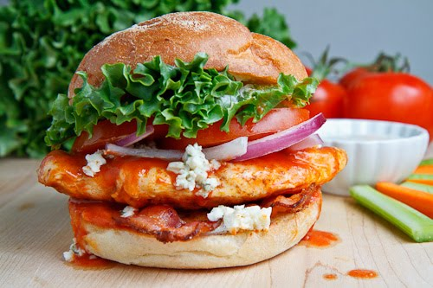

- Fiesta Turkey Wrap
This five ingredient wrap would make an ideal lunch or dinner recipe. This lip smacking recipe would earn you brownie points from everybody who is going to be treated to this delicacy.
Ingredients
- Sour cream
- Salsa
- Flour tortilla
- Sliced turkey
- Shredded lettuce
Procedure
- Combine equal parts of salsa and sour cream.
- Spread this mixture on a flour tortilla.
- Top with shredded lettuce and sliced turkey.
- You can even use avocado for topping.
- Roll tortilla and serve.
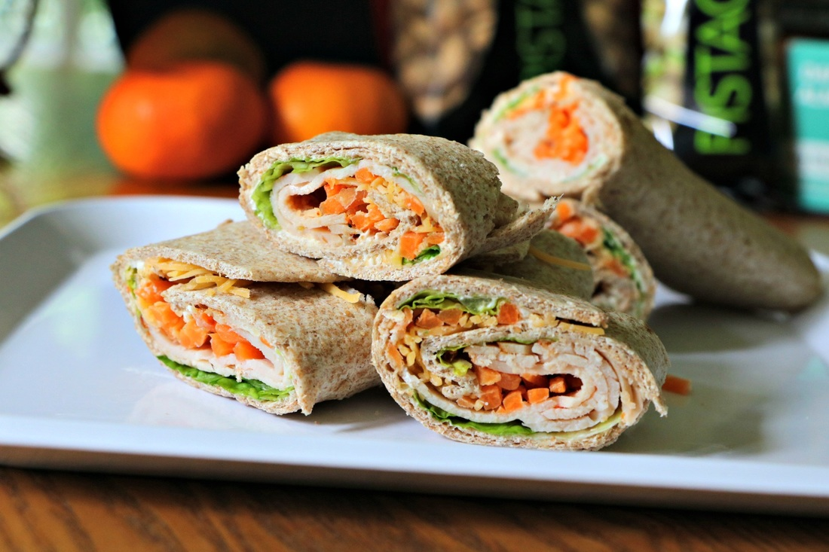

- The Frenchie
Frenchies were quite popular in restaurants during 1960s. This great recipe is an absolute delight.
Ingredients
- 6-inch baguette
- Mustard sauce
- Sliced apple
- Cheddar cheese
Procedure
- Split a 6-inch baguette.
- Slather mustard at the bottom.
- Layer with cheddar cheese and sliced apple.
- Top with other baguette half.
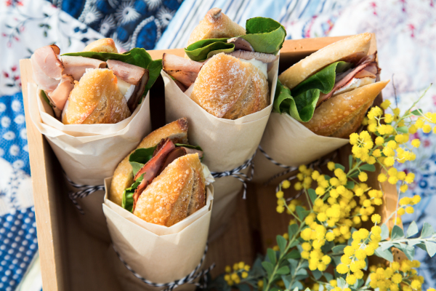

- Sandwich Niçoise
This easy recipe is laden with lip smacking ingredients that would make a wonderful dinner or lunch meal.
Ingredients
- Shallots
- Hard-boiled egg
- Canned tuna
- Pumpernickel toast
- Boston lettuce leaf
Procedure
- Stir hard-boiled egg and chopped shallots.
- Add olive oil and lemon juice into canned tuna.
- Sandwich pumpernickel toast with a Boston lettuce.
- Add the mixture prepared.
- Layer with chopped shallots and hard-boiled egg.

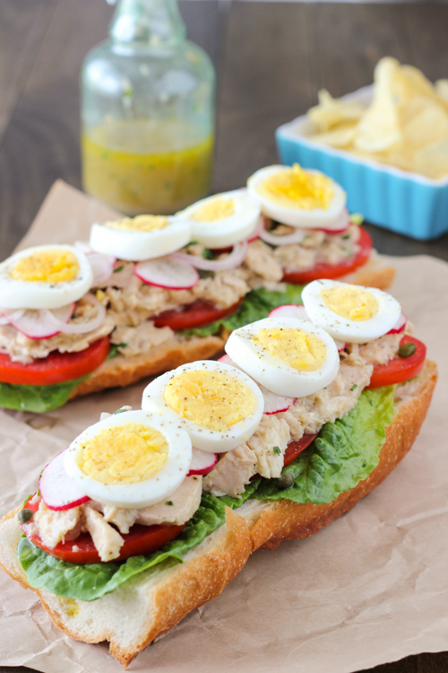

- Margherita Sandwich
A simple, flavorful sandwich made with four ingredients.
Ingredients
- Bagel
- Mozzarella cheese
- Basil pesto
- Sliced tomatoes
Procedure
- Top mozzarella cheese on one half of bagel.
- Toast halves of bagel into oven until the cheese melts entirely.
- Spread basil pesto on the other half.
- Top with cheese and sliced tomatoes.

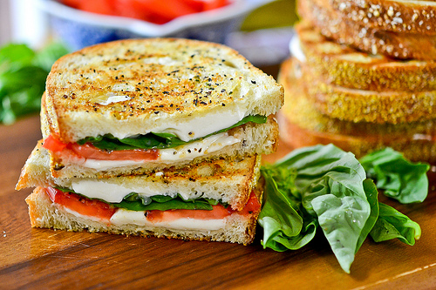

- Veggie Platter Pita
This colorful offering is not just a treat to your stomach but also to your eyes.
Ingredients
- Carrots
- Cucumber
- Cherry tomatoes
- Romaine lettuce
Procedure
- Toss sliced cucumbers, shredded carrots, shredded romaine lettuce and halved cherry tomatoes with your favorite dressing.
- Stuff this mixture into a pita pocket.

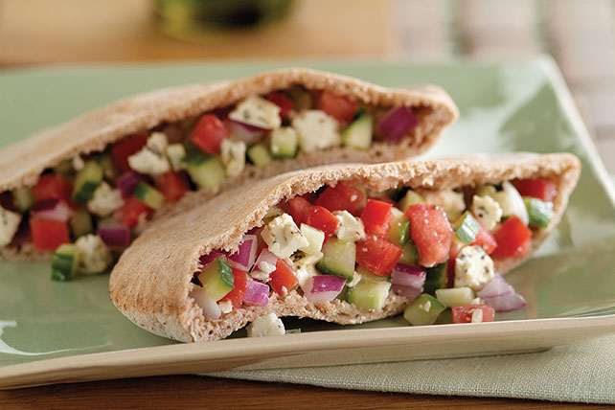

- Honey-Nut Cheese Spread
Looking for something sweet and cheesy? This is a perfect way of emptying your pack of bagel chips or crackers.
Ingredients
- Nuts
- Cream cheese
- Honey
Procedure
- Chop nuts coarsely in a food processor.
- Add honey and cream cheese.
- Pulse the mixture until mixed.
- Serve with crackers or bagel chips.
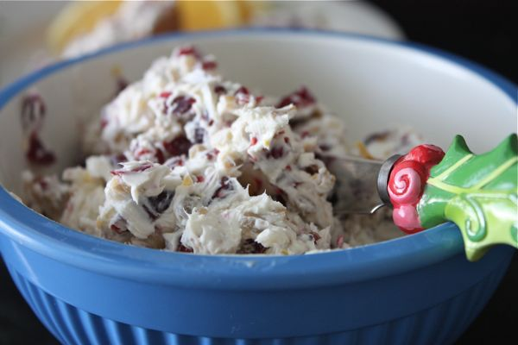

- Tuna-and-Caper Spread
Ingredients
- Tuna
- Butter
- Capers
- Crackers
Procedure
- Combine butter and drained tuna in a food processor.
- Stir capers.
- Serve on crackers.
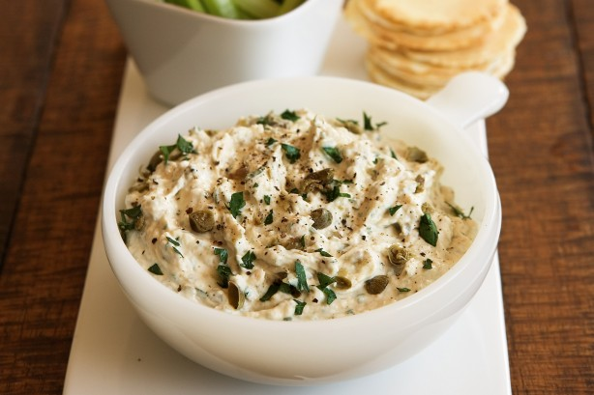

- Quick-and-Mini Pizzas
Ingredients
- Pasta sauce
- Bread or pizza base
- Pepperoni
- Cheese
Procedure
- Spread pasta sauce on pizza base or on bread.
- Sprinkle pepperoni.
- Top with shredded cheese.
- Bake in toaster oven for ten minutes.
- Cut into squares and gorge.

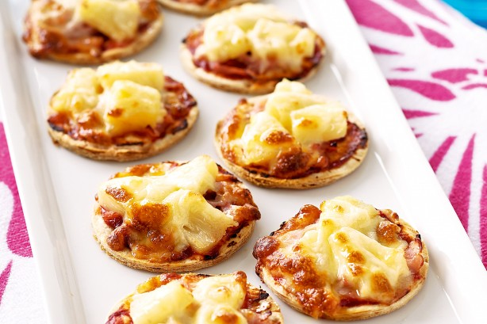

- Marinated Olives
Ingredients
- Extra virgin olive oil.
- Olives
- Lemon peel
- Red pepper
Procedure
- Marinate olives in olive oil.
- Add grated lemon peel and crushed red pepper.
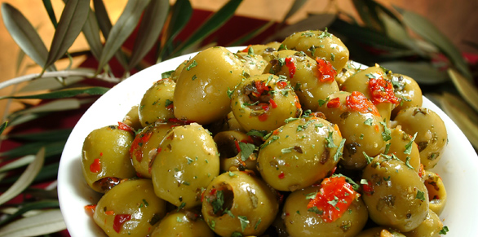

- Black Bean, Red Onion and Corn Salsa
Ingredients
- Black beans
- Red onions
- Frozen corn
- Pickled jalapenos
- Extra virgin olive oil
Procedure
- Combine chopped red onions, pickled jalapenos, thawed frozen corn and rinsed back beans.
- Add little virgin olive oil to this mixture.
- Serve with celery sticks, tortilla chips or carrots.
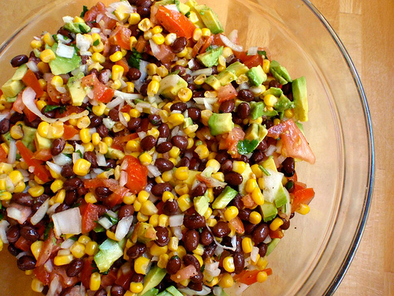

- Coffee Cake Ice Cream
Ingredients
- Crumb cake
- Coffee flavored ice cream
- Pecans
Procedure
- Tear up a crumb cake that has been purchased from a store.
- Stir this into softened ice cream.
- Add chopped pecans.
- Refreeze.
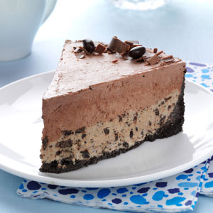

- Fiesta Sundae
Ingredients
- Rum/coconut milk
- Caramel syrup
- Cinnamon ice cream
- Orange zest
Procedure
- Stir a splash of coconut milk or rum into caramel syrup.
- Drizzle this on scoops of cinnamon ice cream.
- Top this with orange zest.
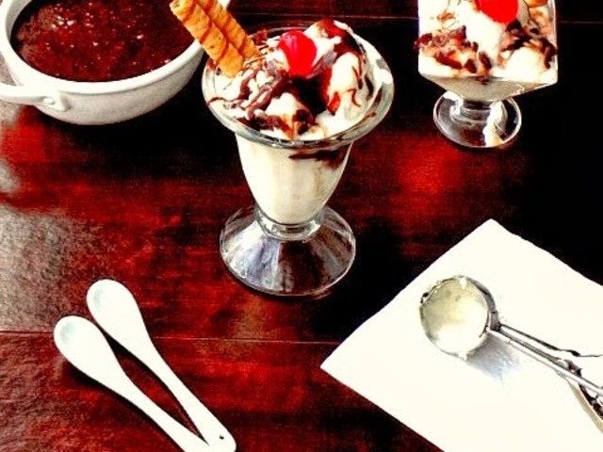

- Not Hot Bananas Foster
Ingredients
- Bananas
- Almonds
- Cinnamon
- Caramel sauce
- Ice cream
Procedure
- Mix toasted slivered almonds, caramel sauce, and cinnamon and sliced bananas.
- Use this as topping on ice cream of your choice.
- Splash with brandy. This step is optional.
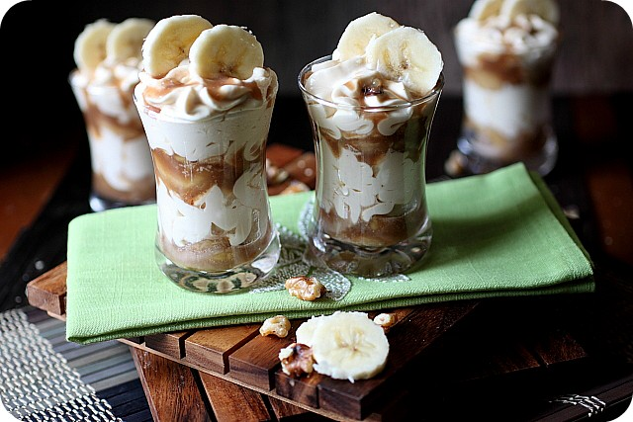

- S'mores Ice Cream Sandwich
Ingredients
- Marshmallow
- Graham crackers
- Ice cream
- Chocolate sauce
Procedure
- Sandwich marshmallow fluff between graham crackers.
- Sandwich a scoop of ice cream of your choice between the crackers.
- Drizzle with chocolate sauce that has been warmed.
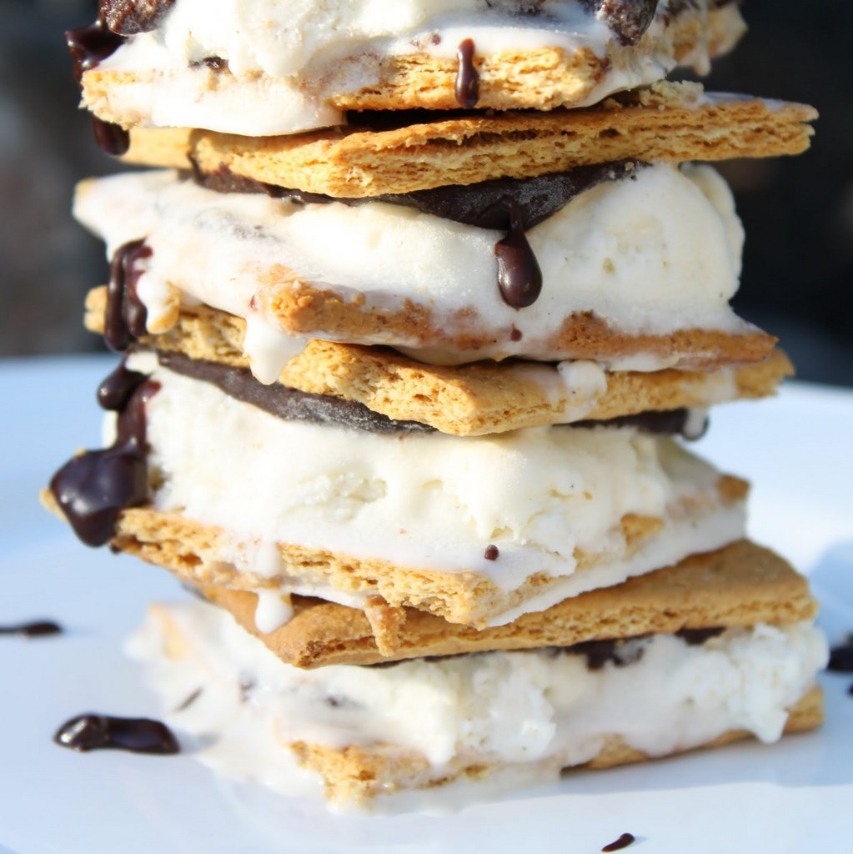

- Peppermint Creams
Ingredients
- Peppermint ice cream
- Chocolate wafers
- Cherries
Procedure
- Mix peppermint ice cream and cherries
- Spread this mixture between two chocolate wafers.
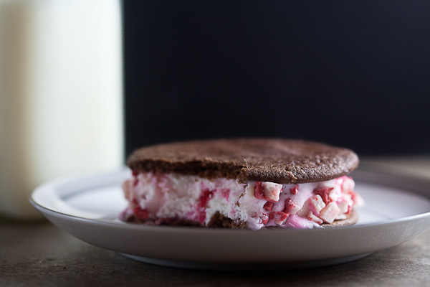

- Easy, Breezy Cheesecake Cones
Ingredients
- Cream cheese
- Whipped topping
- Waffle cones
- Chopped fruits
- Sugar
Procedure
- Mix tub of whipped topping, sugar and softened cream cheese.
- Scoop this mixture into waffle cones.
- Top with chopped fruits of your choice.
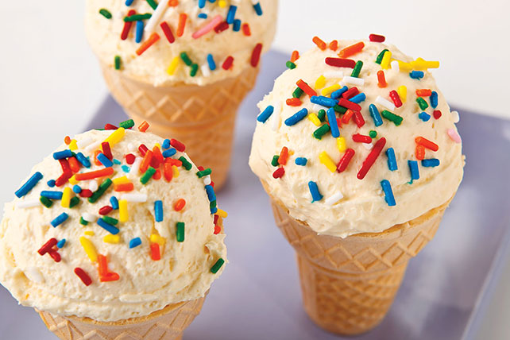

- Instant Tiramisu
Ingredients
- Mascarpone cheese
- Whipped topping
- Espresso powder
- Chocolate shavings
- Rum [optional]
Procedure
- Whisk equal parts of whipped topping and mascarpone cheese.
- Top with espresso powder and rum.
- Refrigerate for thirty minutes.
- Top each serving with chocolate shavings and espresso powder.
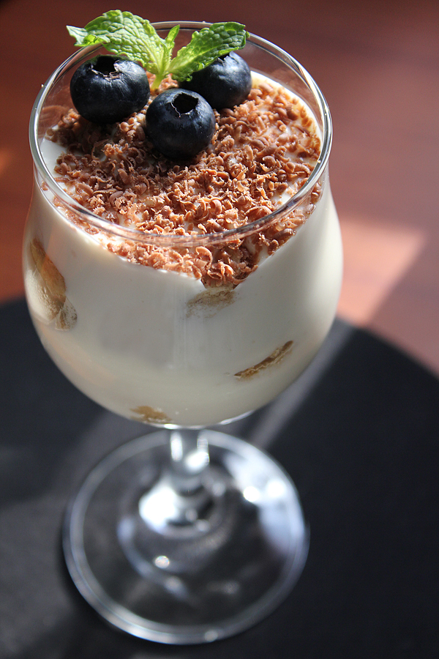

- Cheesecake a la mode
Ingredients
- Cream cheese
- Goat cheese
- Sugar
- Graham cracker
- Strawberries
Procedure
- Mix together goat cheese, sugar and softened cream cheese.
- Spread this on the crust of graham cracker.
- Layer strawberries between the crust
- Chill for thirty minutes.
- Serve with a scoop of sorbet.
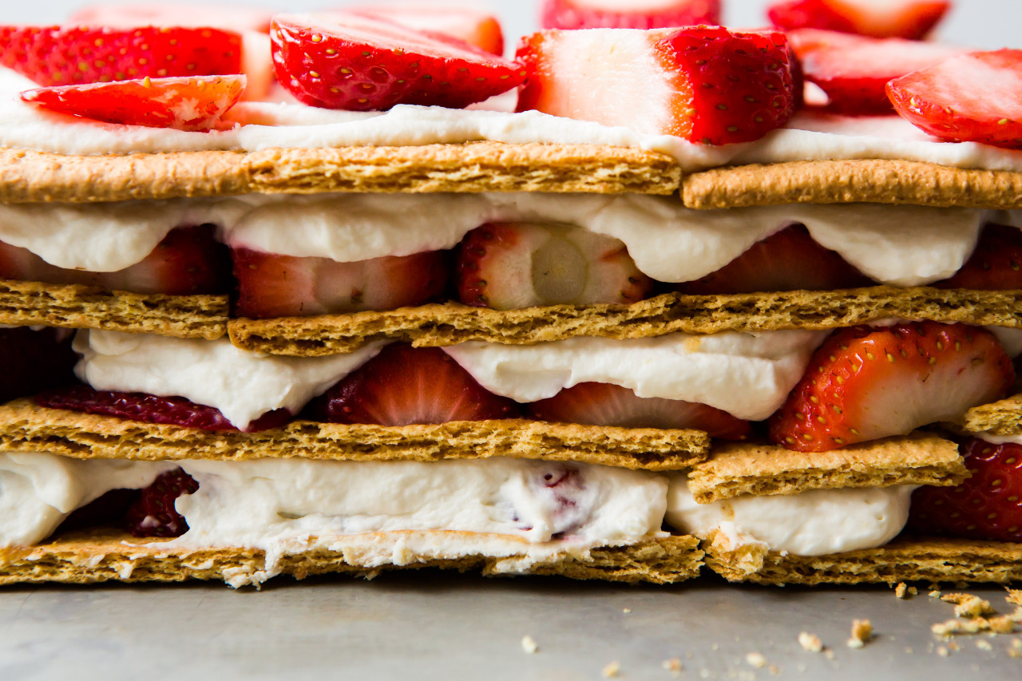

- Lickity Split Lemon Bars
Ingredients
- Lemon curd
- Shortbread cookies
- Powdered sugar
Procedure
- Spread lemon curd on shortbread cookies.
- Chill the setup until it sets.
- Sprinkle with powdered sugar when done.

- PB&B Rice Pudding
Ingredients
- Peanut butter
- Banana
- Rice pudding
- Whipped cream
- Honey
Procedure
- Stir chopped banana and peanut butter in rice pudding that has already been prepared.
- Top with whipped cream.
- Drizzle honey to complete the dish.
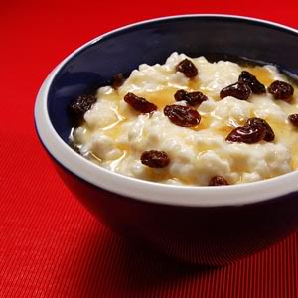
44. Instant Profiteroles
Ingredients
- Toffee candy
- Marshmallow cream
- Pastry bag
- Doughnut
Procedure
- Chop toffee candy.
- Fold this chopped candy in marshmallow cream.
- Transfer the content into a pastry bag with a tip.
- Pipe this into plain doughnut holes.
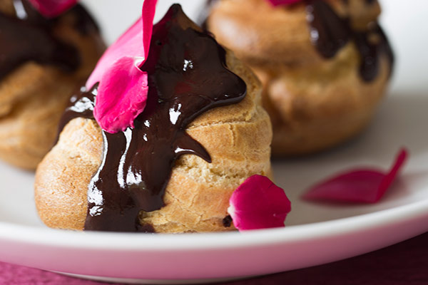

45. Pineapple Pops
Ingredients
- Pineapple juice
- Lime juice
- Sugar
Procedure
- Mix lime juice, sugar and pineapple juice.
- Pour this into an ice pop mold.
- Do not forget to insert sticks
- Freeze
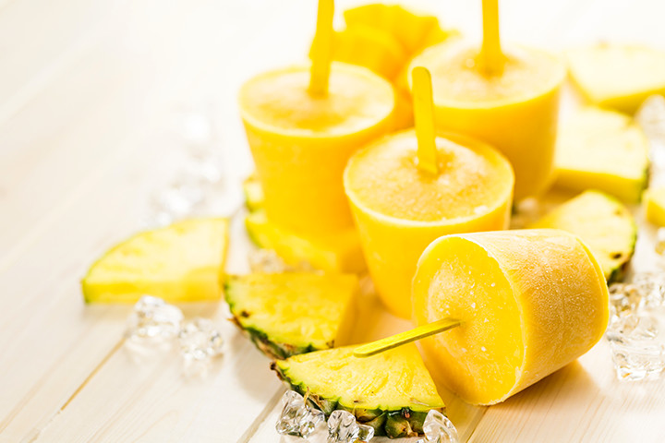

46. Snickers Cheesecake Pops
Ingredients
- Snickers
- Cream cheese
Procedure
- Chop snickers.
- Stir softened cream cheese and chopped snickers.
- Scoop this into ice cube trays.
- Add ice pop sticks.
- Freeze.

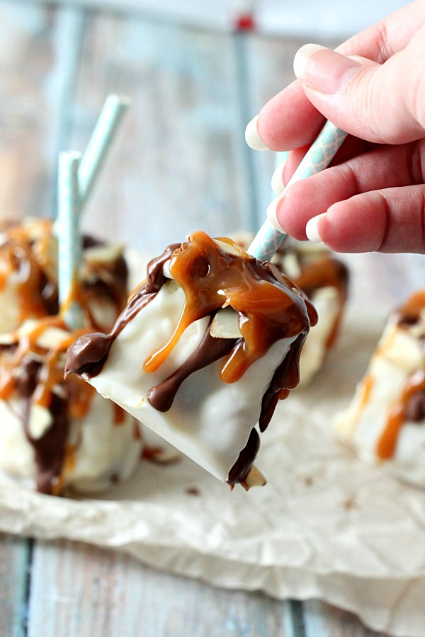

47. Spicy Mango "Custard"
Ingredients
- Mango
- Greek yoghurt
- Ginger
- Ground nutmeg
- Cinnamon
Procedure
- Puree Greek yoghurt with chopped mangoes.
- Add ground nutmeg and sugar
- Top with ginger and cinnamon.

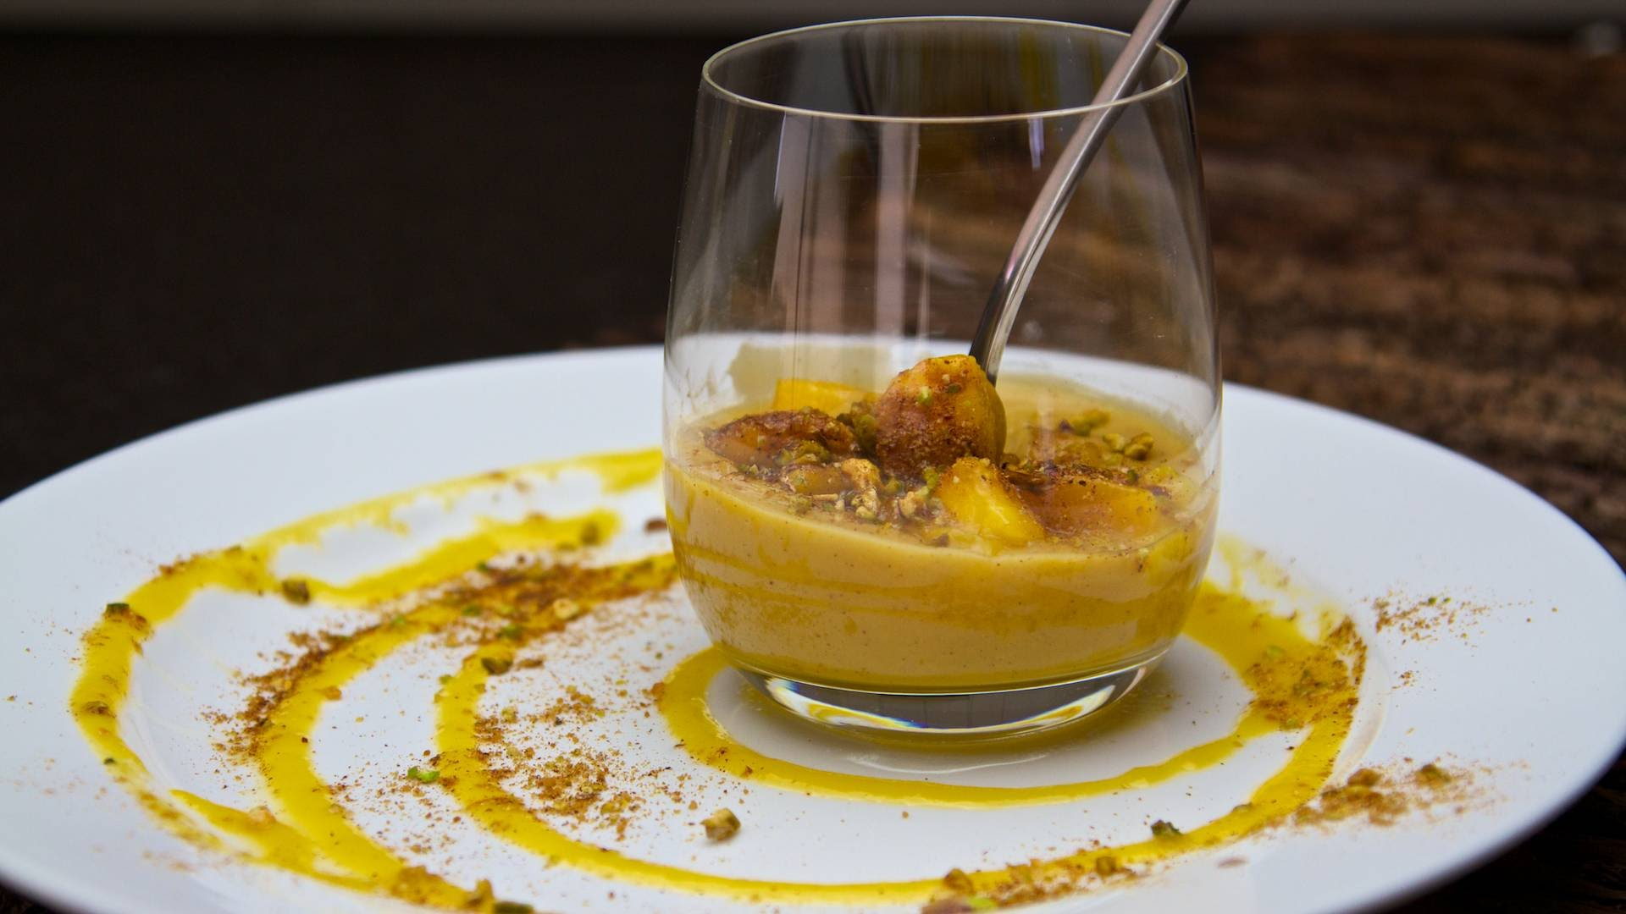

48. Cantaloupe Dessert Soup
Ingredients
- Cantaloupe
- Orange juice
- Lime juice
- Honey
Procedure
- Puree orange juice and chopped cantaloupe.
- Add lemon juice
- Drizzle with honey.

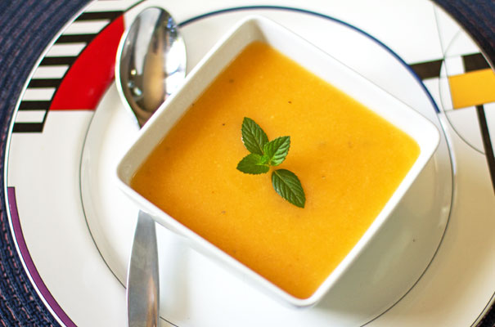

49. Thai Iced Coffee
Ingredients
- Condensed milk
- Coconut milk
- Black coffee
Procedure
- Stir equal parts of coconut milk and condensed milk.
- Mix this into cooled black coffee
- Serve with ice.

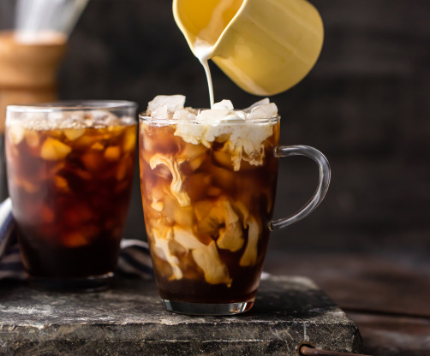

50. Sweet Potato and Carrot Bisque
Looking for something to calm your hunger pangs? Here is a quick recipe laden with nutritious carrots and sweet potatoes.
Ingredients
- Brown sugar
- Butter
- Sweet potato
- Chicken broth/vegetable broth
- Sour cream
Procedure
- Stir pinch of salt and brown sugar into melted butter.
- Do this in an oven proof skillet.
- Add chunks of sweet potatoes.
- Roast this in an oven at 425° for 20 minutes.
- Puree with vegetable or chicken broth with desired consistency.
- Pulse sour cream.
- Top with chopped chives.

