What they do:

Organic Raw Cocoa Butter Soap
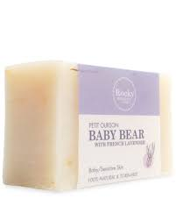
• • •
100% Pure Natural
Description: While strong enough for any user, it is also perfect for sensitive skin, as well as children and infants. 100% Natural Cocoa Butter Soap has immense disinfecting properties, and the rich moisturizing abilities transforms even the roughest and driest areas back silky smooth skin areas into buttery soft skin.

Soaps

Essential Oils are highly sought for use in the hair care industry for their scalp health benefits.

Soaps do not need as much of an introduction as many of our products; as we all use soap daily.
The differences between those other soaps and those we offer however are what set them apart. Our soaps are 100% Natural, as are all of our products. Using no additives, or coloring agents. Any colors or fragrances with our soaps are purely those of essential oils and other natural organic products.
They are designed to keep you clean, and restore your necessary vitamins, such as A, C and E!

African Black Soap
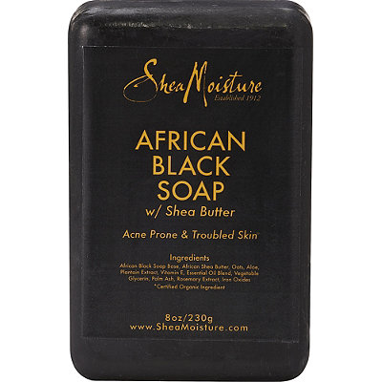
  - For all Skin types
Also called Alata Saminaa, Black Soap is a natural and gentle product, which is also environmentally friendly. As with all of our products it is 100% natural and no chemicals, preservatives or other enhancing agents have been used, simply the traditional Pure African Black soap.

There are several suggestions on using this particular soap:
- It should be stored in a cool dry place, in a sealed polythene bag.
- Those with sensitive skin, should use this product sparingly
- It is not recommended to use this product directly on your skin as it is naturally quite strong
- Lather and dilute Black soap on a sponge or washcloth before using it on your skin.
Aside from keeping your skin clean Black Soap has the following benefits:
- Helps relieve acne and treats oily skin
- It can clean away blemishes and other skin issues
- Soothes Irritation
- A Natural or Organic aid against eczema, rosacea, and psoriasis.
- Due to its strength it is excellent at removing makeup, dirt and oils.
- Maintains a fresh and healthy glow to the skin.
Similar Products:
Himalayan Salt Soap, Lavender Soap, Tea Tree Oil Soap

Home Made Soap

While it is possible to make your own soap at home, and have whichever amount of scents and fragrances you desire added in; this process does usually involve a very caustic and potential hazardous chemical known as Lye. While a necessary part of most soap making processes; Lye can be even be deadly if ingested. We do not want to offer any information that would potentially lead to injury of any sort, as such we would suggest to not undertake these projects on your own.

Simple DIY Recipes

