I had been with my bank since 10 years, and when they refused to give me a loan-, I realized what a big deal credit history was! With no other options to get some extra money to take care of my affairs- a friend recommended MoneyMitra, and since then, not only have I been able to take care of all my financial woes, but have also taken care of all my long-standing debts and loans!
Avinash Manchanda
Jalandhar

I did not know a lot about banks and money matters- and had been searching for an easy and trusted source to get a loan. When my bank turned me down- I was out of options, but thankfully, someone recommended micro-loans to me, and that is how I found MoneyMitra. Their amazing customer service, transparency and easy-to understand procedures helped me take care of my matters in no time.
Sanjeevini Kaushik
Rohtak
If you are someone like me- who does not have a lot of time and patience, and are looking for a quick and hassle free way to get a small loan, then this site is just for you. You will find everything within seconds- and you can be sure of them being there for you all the way. I have been with them for more than a year now- and they are the first and only website I visit when I need a loan.
Kritesh Malik
Jodhpur
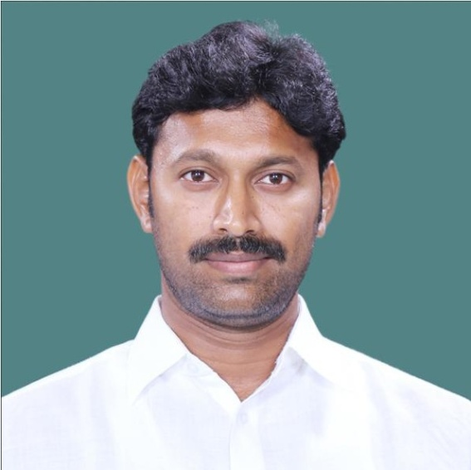

Being from a small town, I only had two ways to learn about my loan options- the local bank and the internet. Thankfully, I chose the internet, and that is how I found this site. Since then, they have been one stop for finding a loan. In fact, it is so great that even my relatives have now become their loyal customers. Convenient procedures and a great customer service- what more could you ask more.
Kabir Khattak
Fatehabad (Haryana)
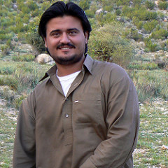
As my business failed and debts rose, getting a loan from any bank become next to impossible. That is when I came across this website- and I was able to get a loan within no time. It helped me stabilize my business, pay off my debts and get back to a profitable stage! I recommend it to everyone who needs a quick loan without any of the usual trouble that banks give to their customers.
Jairam Girish
Ahemdabad
