Universities go online for student recruitment
Social media is taking business organizations to proceed to the next level. With all the industries using it to be a marketing tool, the educational institutions are of no neglect. Yes, the educational institutions have started using the online services and social media to promote their universities, schools and colleges to go beyond boundaries.
SOCIAL MEDIA
Social media networking sites like Facebook, Twitter, LinkedIn, Google+ and others can be used for international and national student recruitment. However, it is necessary that the posts and the account are regularly updated and frequently monitored. This is to make sure that the international students get to know the happenings of the university and get themselves prepared for the recruitment.
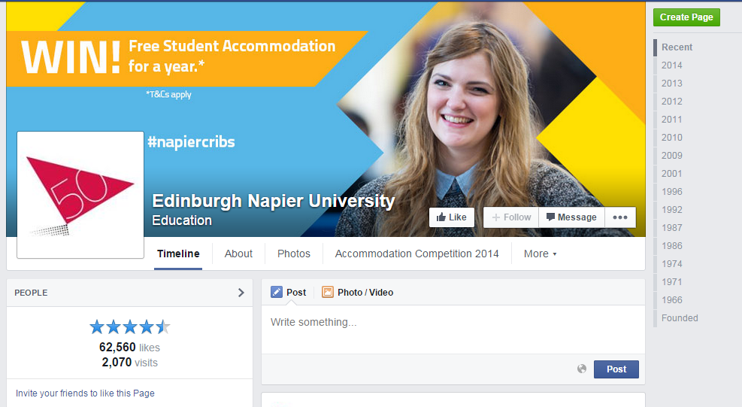
INTERNATIONAL STUDENTS GROUP/ASSOCIATION
The Universities can form a student’s group in the social account site and encourage their students to join in the group. Doing so, the past, current and future students all will be connected through the group and communicate with each other. This will enable the international students to verify their clarifications with the current university students. Or on the other hand, people can also create an Active Discussion page for the students to make their open discussions there. However, it is the responsibility of the university to maintain the privacy policy against the discussions made.
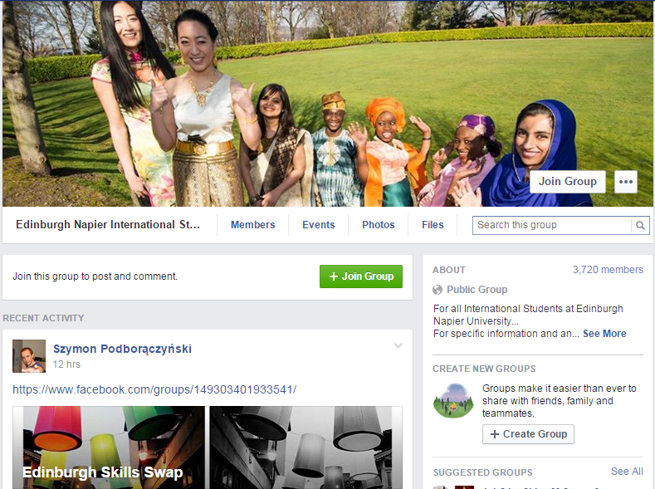
STUDENT AMBASSADORS
Elect international students as student ambassadors in the university. Give them the confidence to communicate with others. Encourage the student ambassador to involve in extracurricular activities. As a Student ambassador, they will be forced to respond faster and communicate with more students and staffs which in the long run would make them feel at home and obviously they would tend to make actions that would help the other international students as they know what all the problems they would face.

OFFICIAL SUPPORT
The universities should give official support for the students before recruitment. Universities can make use of the latest technology advancement like Skype for fixing an interview with the students. Let the students know about the international recruitment agencies that you have tie up with. In recent days, students are getting trapped by spam agencies using different universities name. Therefore, you can help the international students from getting into the trap. So, respond quickly to the enquiries that the student sends over the social account or through mail or contact form in the website.
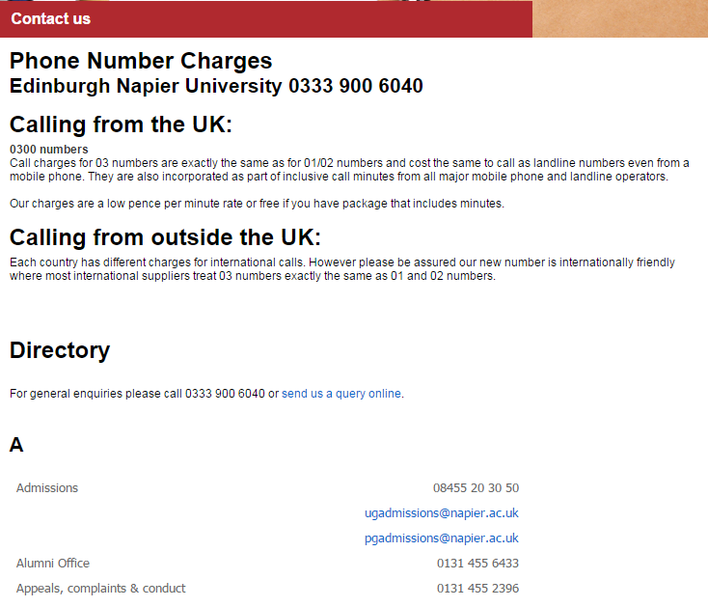
WEBSITE CLARITY
The website of the university should be of interest to the visitors. Students or parents who visit the website will not spend much time on the whole content. So, make it precise and clear. Highlight the links through which they can find information. Make it neat and clean. Provide the list of professor’s profile and be true with your website content. Make sure the viewers get what all information they need. Welcome the viewers with a note and ask them to fill a short survey when they are about to leave. Make use of online chat system to help them to come to a conclusion in case if they have any queries.
