I Spring RCC7 Reverse Osmosis System review

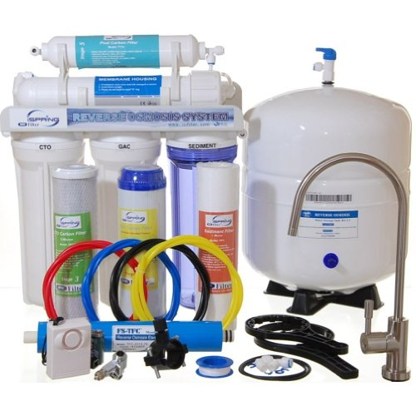

Overview
The onset of too many chemicals in the tap water and numerous bacteria just rooming around, water cleansing has been a major concern. The cost of buying bottled water every day is a costly burden. That is why the reverse osmosis system was developed for clean and healthy water. The system uses a process where a highly concentrated water solution is put under allot of pressure through a semipermeable membrane to a less concentrated solution.
Established in the 1950’s the technology was employed so as to purify salty water and make it fresh and humanly consumable. Reverse osmosis can be used to desalinate and clean water from impure minerals. I-spring RCC7 has up to 5 filtration stages which can be produced at 75 gallons every day. This guarantees you of constant supply of fresh water ready for your domestic consumption.
Features and performance
The systems has 5 filtration stages which incorporates, carbon block (CTO), polypropylene sediment (PP), granular active carbon (GAC) and reverse technology ensuring a tasty and clean water. Some of the hardware devices used in purifying the water in the systems includes.
- 5micron 10 inch high capacity polypropylene sediment filter – Which removes sediments, dusts, sand, particles and rust
- 5 micron 10 inch GAC – This one eradicates chlorine making the water clearer and odorless.
- 5 micron 10 inch carbon block – Responsible for removing any residual color, tastes and odor.
- 0.0001 micron high rejection TFC reverses osmosis membrane – This is the filters which transforms the water from a more concentration component to less concentration.
- 10 inch polishing inline carbon- removes any possible residual odors from the tank
- Tank- 3.2 gallon pressurized tank
- Faucet- Lead free, long reach, goose neck water delivery.
- Tubing – Transports the water from one point to another
All the above components are certified to meet the NSF/ANSI water standards.
The purification process
Water is first filtered for sediments and dust particles. This is by use of a high quality sediment filter known as the polypropylene sediment. The next stage is whereby the granular active carbon filter removes chlorine, tastes, odors, cloudiness colors and other chemicals. The third step is when the carbon block further removes any remains of residual color, taste and chemicals. Other additional filters for instance ultra violet sterilizing may be added to get extra effects. The next step is when the water is put under pressure through the semi-permeable membrane to reverse osmosis. This is the most important part of the process and involves usage of the reverse osmosis membrane. This stage not only removes any microorganisms, it removes lead chromium, copper, sodium and other water contaminants. This technology is employed during production of bottled water. The final stage involves filtration of the water when it leaves the storage tank after the user has manipulated the faucet for water.
The whole package comes with a user manual which details the step by step installation procedures. User can also seek assistance from their vendors on any issue needing clarification. The pre-installed automatic shut-off valve and the check off valve automatically shut off the system when the tank gets full. These are some of the components available which enhances the user’s experience
Why choose the I-spring RCC7 ROS
I-spring reverse osmosis system is an effective and reliable water management system. Its efficient daily production of 75 gallons will give your home an endless supply of clean, tasty and fresh water for consumption in its 3.2 gallon storage tank.
The advantages
- Clean fresh and very tasty water – The whole purification process will not only leave your water clean but free from any unhealthy contaminations. As articulated above, the semi-permeable membrane works effectively leaving you with an up to 99% solvent free water.
- Value for money –This is a worthwhile investment and users can enjoy its use for up to 6 to 12 months. Other water purifiers are known to last between 30 to 60 days before getting upgraded.
- Economically sound – Why waste money constantly buying bottled water? This will most certainly sort your water problems making even that chemically filled tap water taste much sweeter.
- Portability – The reverse osmosis system is easy to carry and can be mounted easily at a preferable position.
- Friendly management systems – It allows users to monitor the water levels quite easily. Thanks to the pre-installed storage tank valve and the automatic shut-off valves, the water tank automatically shuts off at certain water levels. A water level alarm is also available which signals the user to avoid spillage.
Disadvantages
- Costly – Investing in a reverse osmosis system is costly.
- Wastage – The system filters allot of water leaving up to two thirds of the water being wasted.
- Installation and management – Installing the hardware components together might not be that easy for everyone. In addition to that, many people also find user manuals boring to read. The hardware also requires frequent replacements. This tends to be tedious and cumbersome. Constant cleaning of the semi permeable membrane is also necessary.
Consumer reviews and recommendations
The customer feedbacks from those who have enjoyed the use of the system have been over 800. This has yielded a customer rating of an average star of 4.6 out of 5. This is indeed a remarkable rating and here are some of the customer reviews.
Most people loved the tasty water after filtration, the durability and the value for their money. The cost saving aspect garnered quite a number of five stars.
However there were challenges encountered by customers in installing the 7 stage version. The other concern was on the UV light which gets too hot even when the system is not in use. An automatic mechanism to switch the UV tube off whenever it’s not in use should be installed.
The water purification system comes with a one year warrant from the date of purchase with a thirty day pay back in case of unsatisfied customers.
Usage and maintain
Ensure you have correctly and properly installed the system. This can be guided by the use of the manual in the system’s package. Mount the system to your water supply probably the kitchen tap. Open the tap water for it run through the steps as it cleanses and purifies the water. An additional pump to boost the water pressure may be required if your water doesn’t meet the 45-80 psi pressure required. Make sure the water temperature is at 37~`4 degree Celsius, at a pH range of 3-11 to avoid damaging the system. Soft water is also highly recommended.
Periodic checking on your system and changing the hardware is important to ensure your system serves you well. Worn out filters ought to be changed frequently. When you are replacing the carbon filter, ensure you drain the tank of water before restarting the system. The O-ring should be replaced after 3 years to strengthen its grip. Leaking areas need to be tightened or replacement of the O-rings.
Conclusion
Water is a major ingredient to a healthier and energetic individual. Drinking water daily is recommended by most health experts. This system is surely a savior and produces very tasty water. The I-spring RCC7 reverse osmosis system will be the answer to your clean water concerns.

