Chapter 7-Creating an Affiliate Store

Introduction

It seems quite lucrative option to generate money through passive income source. People are lured by the idea of making money by putting in least efforts. This is the reason why creation of an affiliate store is being considered by a lot of people. When you intend to create an affiliate store, you aren’t actually involved in the core business. You just market a business that already exists if you run a blog for instance.

With your affiliate store, you can make a living if you diversify your affiliate sources. You can consider having various affiliate sites. However, it requires a lot of time and efforts to make it click. Having an affiliate store just makes you a part of the sales of a particular company.

How to Build an Affiliate Store?

You know that you can generate passive income by selling affiliate products. But how does one build a store that is solely dedicated to selling affiliate products? What are the procedures involved? There are several ways in which you can accomplish this task. Creation of an affiliate store can be an awesome way in which you can generate a passive income.

Selling of affiliate products is an excellent business idea where you aren’t involved in creation of products. You don’t even have to deal with customer service or shipping. All you need to ensure is that you deal with products that are of high quality or else you may end up hampering your reputation during the process.

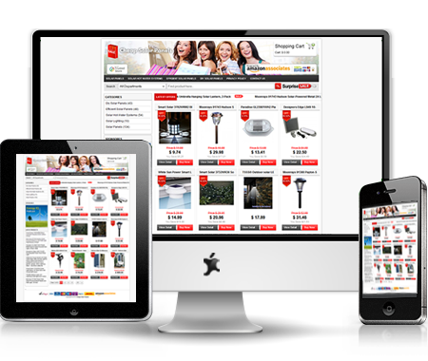

Requirements
You certainly need to be a part of some affiliation program if you intend to run an affiliate store online. For instance, you can consider the Amazon Associates program which is highly popular. Whenever you sign up for this program by Amazon, you end up promoting the products which are listed on the e-commerce website. You end up earning a provision for each sale made through your store.
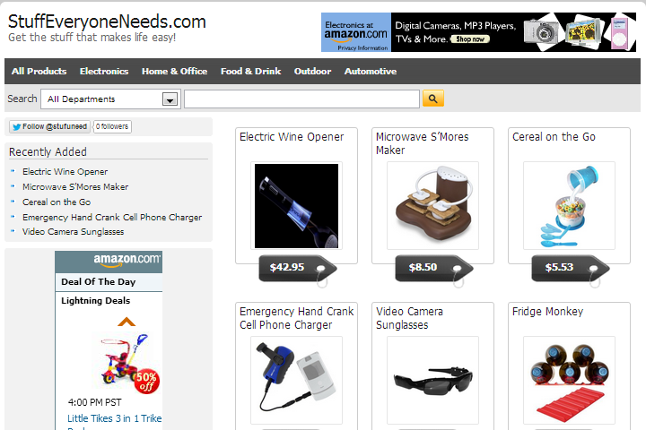
In addition to being a part of any affiliate network, you would also require to have WordPress installation to begin with. There exists a theme referred to as the “Covert Store Theme” that can be procured after a nominal payment. This theme loads the products automatically from the Amazon Associates network onto your WordPress page. You need to decide which product you wish to promote from the website.

Get the Products
It is quite easy to import the products in an efficient manner when you utilize the Covert Store Builder. You just need to search for the products which results in a listing of the products and you can easily choose what you wish to feature in your affiliate store. The pricing, description and images are as well loaded automatically when the Covert Store theme is utilized.

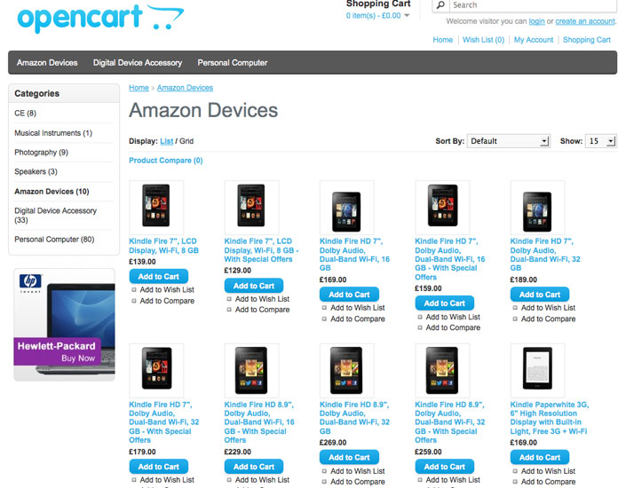

You’re ready to run after setting up the store

Whenever a visitor clicks on the link placed on your affiliate store, they get redirected to the actual page of the product on the affiliate network. If you have placed links through Amazon Associates program, then the person visiting you site gets redirected to Amazon site where the product has been placed for sale.

You need to be, however, careful when you are placing links as a part of your affiliate program. If you do not do it carefully, you may the following issue:

Duplicate Content: You need to be really careful in order to avoid placing duplicate content on your site. Your affiliate store would make money only if it ranks well in the search results. As you import product information from another site, your content would be considered to be duplicate and your store webpage wouldn’t receive a good ranking from Google.
How to Make Money through Affiliate Products?

There are numerous manufacturers out there who have to sell their services and products. You can help them do that and make a commission on each sales task accomplished. You don’t really have to physically sell any product or take any payments. You don’t even have to bear the responsibility of shipping. You wouldn’t have to deal with returns, refunds and the customers. Can it get any better than this?

An affiliate company offers you payment whenever a visitor to your website accesses the link which redirects them to the products that are being sold on the website of the company to which you are affiliated.

How much commission can one make?

You must be wondering about the commission that can be made by you by starting an affiliate store. The commission offered differs from one affiliate company to the other. Downloadable software and information products fetch anywhere from 50% to 75% commission. Services and products fetch a commission in the range of 5% to 10%.

What does the task involve?

Affiliates require you to post their tracking links and banners on your website. This can be done easily with a simple copy and paste process. You can even consider using sophisticated tools as they can engage the visitors for a long time. Whenever, a visitor clicks on the link, they get redirected to the affiliate website. You also earn commission when a customer keeps coming back and makes purchases. You need to discuss with your affiliate the time frame your membership is limited to and the benefits that you can reap with the program.

Tips for making big profits through the affiliate program

To be honest, the world of affiliate marketing is quite competitive. The online industry is overly saturated and day by day people are getting skeptical about making purchases from sites that aren’t much renowned. You will have to figure out ways in which you can make money of your affiliate program. You need to experiment with the techniques to figure out what works for you and what doesn’t.

There exists serious competition when it comes to marketing products on the Internet. You need to know how to find people and the right products through which you can make a decent passive income. This is an art in itself.

Do you have a decent audience size?
Whenever you are planning to make money through an affiliate store, you need to figure out what it takes to succeed in the venture. You need to have a site with a decent audience so that you can market the affiliate products. You need to make sure that you place ads which are more or less similar to whatever you offer. For instance, if you run a beauty blog, you can place beauty products that are sold on Amazon through the affiliate program. The chances are pretty high that people would want to purchase a product that has been featured on your blog. Target the audience well. Indulge in efficient marketing strategies. In this way, your blog would receive popularity as well as you would make money through your affiliate program.
The general rule that applies here is, the more people you connect to, the more money you can make out of the program. You also need to ensure that your visitors are engaged in your activities. You need to make sure you layout everything appropriately in front of your audience so that they get tempted to indulge in the services and products being featured on your web page. The more popular is blog is the chances are quite high that you would become successful at your affiliate store venture.
Free Content
The nature of blogging highly influences your affiliate program. For instance, if you run blogs that offer free content or information, then your audience is limited to people who are just looking for free content and have no interest in making any sort of purchases. Your affiliate plans wouldn’t click for you, if you run such blogs that offer free information.
If your blog covers consumables then you can really do well in your affiliate program venture. If you own a blog that offers information about cell phones or laptops, then the chances are quite high that the people visiting your blog are the ones who are interested in making a purchase of a product. Why would you want to read a blog about a cell phone if you aren’t interested in making a purchase? You would do so as you would be considering purchasing the device in the near future.
You have an upper hand in the affiliate program, if you run a blog that features consumables. Stick to an affiliate membership if you run such blogs. If you do not have a blog that features services or products, then you must consider having one especially if you are serious about making money through affiliate membership.
Reviews
Blogs have a bright future and there isn’t any doubt about it. Almost all people stick to blogs that offer them any sort of information that they are looking for. There are barely any consumers left who do not go through blogs for product reviews. With millions of products in the world, there isn’t any doubt about the future of people making passive income through running an affiliate store. Blogs that offer product or service reviews prove out to be a successful platform for affiliate venture. This is because these offer promotion which is kind of soft sales manner. When people value the advice you offer, the chances are high that they would stick to your recommendations offered in the form of affiliate links.
Just build a good blog and work towards making it popular. With highly targeted visitors, your venture of affiliate marketing will make you decent income. A blog that is popular also receives good search engine rankings. This will make sure that you just benefit from all sides.
Offer Authentic Experience
There are several blogs over the web. Not all perform well. This is because people aren’t aware of the manner in which they should develop content that sells. Not everybody is a born writer. But they can certainly learn how to write a review that sells over time. With so much of content being offered on the web, this shouldn’t be difficult at all. Become a better blogger if you wish to be successful at other things.
Reviews are of two kinds: A positive and a negative one. If your reviews do not sound convincing to people, it is utterly pointless to have an affiliate membership with any company. This is because the products would in no way sell especially if you seem convincing enough to your audience. You cannot make any kind of sale by posting a negative review about any service or product. Have a clear mindset. If your sole purpose is to earn money through affiliate programs, then make sure you run a blog that offers reviews that can tempt a visitor to indulge in the service or the product.
Reviews must be structured well and shouldn’t sound boring to the audience. Stick to the point and you must also be in a position to answer the questions posted by the reader. Only your experience can help you with this. Make sure you are authentic. You should be in a position to offer authentic advices or else the traffic to your blog would decline over time. For instance, you are reviewing a beauty product that is suitable for people with dry skin then you need to advice people of other skin kinds to stay away from the product. If you fail to do so or try to furnish false information, then people would refrain from visiting your blog and this can prove out to be fatal for your blog’s future.
You need to maintain a healthy balance of blogging and affiliate marketing. You need to figure out what clicks and works with your audience. If money is all you need, then ensure that you indulge in promotions of products up to the point is starts messing up with your traffic. Over emphasizing can kill the interest of your audience and turn them away from you. You need to learn when and where to draw the line.
It is vital for you to understand that your affiliate marketing program grows only when your readers get engaged with you to a point they start trusting you entirely. Once a level of trust has been established, they wouldn’t shy away from taking your suggestions.

Segmented Email Lists

This is a piece of advice every blogger interested in reaping benefits from affiliate programs must follow. Build an email list! You cannot wait for people to just come in and check out the reviews and make a purchase from the affiliate site. You need to have a loyal audience that will keep coming back to you. Having an email list will help you connect to your readers to an another level, which will have them coming back to your for more. This will help you keep a healthy traffic towards your blog and establish a relationship with your audience.

Email marketing plays a crucial role when it comes to marketing any product or service. People keep constantly checking their mails. Blogs require attention and hence consumable blogs can benefit a lot from email marketing. You can consider using a combination of email marketing, reviews and blogging to be successful in driving affiliate sales.

Common mistakes to avoid in affiliate marketing program

The most common manner in which people build their affiliate store is through their blogs. However, there is a lot to consider when it comes to affiliate marketing with the aid of blogs. Here are a few things to consider when you are involved in affiliate blogging. Here is a list of mistakes that you need to avoid in order to be successful at your affiliate blogging venture:
- Do not post banner pertaining to affiliate promotions everywhere on your blog. Make sure that you run a content rich blog from which people benefit something. If you just indulge in posting ads and offer no good content, then you would probably make nothing out of your affiliate blogging.
- Do not copy and post any sort of promotional content into your blog directly. There are several affiliate programs that offer content and emails to the bloggers for the purpose of marketing. This doesn’t work well all the time.
- Never offer a promotional review that praises a product overly that it deserves. Whatever the product is, remain honest. Your readers would appreciate your honest review and would stick to your for years. If you indulge in any sort of false praising then it may cost you your audience.
- Do not blog about anything or everything. Just because a product launched in the market doesn’t imply that you need to blog about it. You need to refine the content you post on your blog and also ensure that your readers reap something out of it. If something doesn’t suit the style of your audience, then refrain from blogging about the product. Think before your blog! Understand what your audience is interested in.

Affiliate blogging is a wonderful way in which you can generate a decent passive income. If done appropriately, you can immensely benefit from setting up an affiliate store. Develop an awesome blog with a wonderful following to reap the benefits of affiliate marketing. With a lot of people sticking to blogs for product and service reviews, affiliate marketing can help you set up a stable passive income.

References:

- EntrepreneursJourney. 25 01 2016 <https://www.entrepreneurs-journey.com/795/affiliate-blogging/>.
- Income Activator. 25 01 2016 <https://www.incomeactivator.com/17335/Selling-Affiliate-Products.htm>.
- Three Ladders Marketing . 25 01 2016 <http://threeladdersmarketing.com/learning-center/how-to-make-money-from-affiliate-marketing>.
- Wordpress. 25 01 2016 <https://wordpress.org/plugins/easy-affiliate-store/installation/>.

