Chapter 6 - Create an Investment Portfolio

Introduction

Whenever, the topic of investment comes up most of the people think of having their retirement accounts. Creation of an investment portfolio not necessarily implies that you are on the verge of retirement. This can be viewed as a passive income source that can help you generate extra cash to support your family or lead a much better lifestyle. Investment can also imply that you are setting the right stage for your distant future. Creation of an investment portfolio in fact can start benefiting you right now.

Building an investment portfolio can help you create a source of stable passive income. This can also help you create a long term investment. There are several options that one can consider when it comes to the generation of a passive income. The subsequent paragraphs offer an insight into how one can have their own income portfolio.

What is meant by Income Investing?

An income portfolio refers to a collection of investments that offer you a regular source of income. This implies that you would be receiving money on a regular basis either semi-annually or annually. You may even opt for quarterly returns without any need for selling your investment.

An income portfolio is comprised of various investments that offer a decent predictable return. The following investment sources can be included while creating an investment portfolio:

- Dividend-Offering Stocks

Dividend stocks offer a portion of the profits reaped by the company at regular intervals of time. You don’t really have to sell your stocks for the purpose. You get payments issued by the company for the number of shares possessed by you. This payment is more or less similar to the sharing of profits as you receive a fraction of the profits made by the company.

- Bonds

Investment in bonds implies that you are lending money to some organization. You earn interest for the money lent all through your life. You get back the principal amount when the term of the bond expires.

- CDs
When you invest in a certificate of deposit, it is possible for you to earn interest over it throughout the tenure of the deposit. This is considered to be a safe investment of your money that you can make.

- Annuities
These must be considered with careful planning as these are quite complex. Few people who have an in depth knowledge about these consider including these in their income portfolio as these offer a regular payout.

- Micro Loans
Your income portfolio can include the loans that you have offered to others. As you get back the principal amount along with a certain amount of interest, you receive some sort of regular income when you offer micro loans. There are several investors who retain the interest and invest the principal amount again.

How to build your income investment portfolio?

The best way to begin building your investment portfolio is to carry out a detailed research and also indulge in a little bit of number crunching. Here are three parameters that can be considered while trying to build an investment portfolio.

- Capital consideration
In order to receive a monthly income source almost immediately, you would want to have a large capital chunk ready with you to begin with the investment process. For instance, you cannot purchase all your groceries from the interest earned for a single treasury bond of $500. You would require to invest a minimum of $150,000 if you require any annuities immediately.

If the figures are scary, you need to remember that you have to tackle things with a strategic approach. Building an income portfolio requires careful planning and investing little bit of time.

- Are there any risks involved?
You need to figure out the amount you can keep aside every month in order to create your income portfolio. You can use the amount in purchasing investments. You also need to set a risk tolerance limit once you start building your income portfolio. There are several cases in which the organization on your bond could be charged off. Moreover, there may be scenarios in which the companies that offer annuities may get shut down. This could in turn result in your dividends getting cut.

- Go slow
The best way to start building an income portfolio is to consider investing in stocks that pay dividends. You can consider purchasing partial shares. You don’t require a huge capital to purchase the entire share in a go. You can consider investing in income oriented funds that are a combination of bonds and stocks that offer dividends. You can consider slowly building your investment portfolio that it becomes big enough to generate a stable income for you.

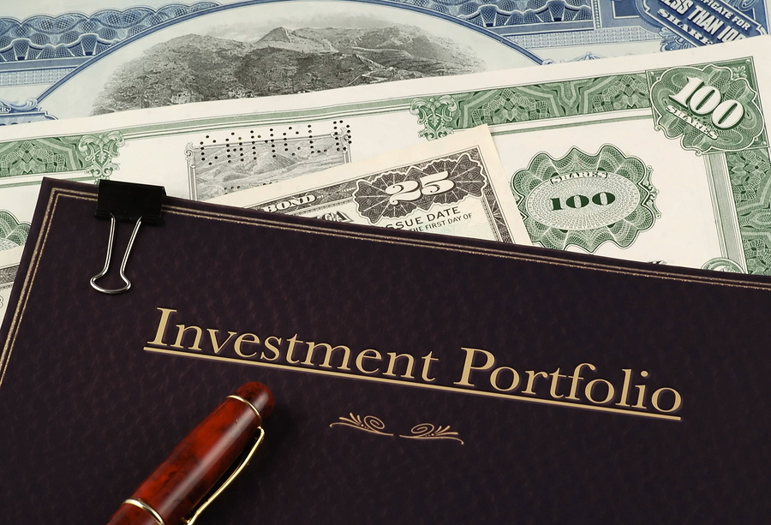

The word “investment” doesn’t have to be associated with retirement. You can consider it as a source of additional income that can be used to help you out whenever needed. If you invest right now, you can harvest the fruits later on. You can build a strong foundation for your future when you carefully plan building your income portfolio.

Building a portfolio is really important and there are many investors who understand the significance of doing so. Smart investors believe in keeping their money in a plethora of asset classes. They also consider re-balancing their investments.

Building a strong investment portfolio

You can consider the following principles in order to build a strong portfolio for yourself. You can consider adopting the three bucket approach. It is crucial to have a cash cushion of up to expenses for six months. This would help you avoid selling your investments in case there is an emergency. The second bucket you need to consider is your investments for the retirement period. You should offer a very large component in this sector and must handle this pretty consistently. This should be the core part of your portfolio. The third bucket is the “explore” option in trading where you do not mind losing a little bit if things don’t work out the way you have planned. You can minimize trade losses owing to emotional trading if you set a separate portion for your risky investment ventures.

While picking stocks, you need to decide how you would carry out your asset allocation process. You need to have a proper mixture of bonds, stocks and various other kinds of investment options. Your long term investment has a biggest impact if you have your portfolio balanced. The entire process of building your investment portfolio can become easy if you follow basic rules.

- Goal considerations
You need to be aware of the time when you would be needing money and also the amount. This should be done when you start off with the entire process.

- Time curing
When your plan is to save for a long term, the volatile investment returns can be smoothened with time. Volatility in assets seems great when the value of assets shoot and seems scary when they are tumbling down. You need to have a long term perspective when your assets are volatile.

- Keep an eye on inflation
Anyone in need of a fixed income has to bother about the damages that inflation could cause on the payments through annuities or bonds. Inflation effects can be moderated by owning Treasury Inflation Protected Securities [TIPS] and owning commodities.

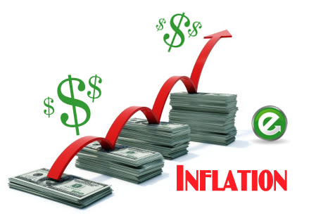

- Consider the risk parameter
Investments always have a certain amount of risk associated with them. This even includes investments that are considered safe such as Treasury bonds or blue chip stocks.

- Invest in a variety of assets
You can reduce the volatility in our portfolio with the addition of alternative assets such as real estate or commodities. Inflation can be counteracted through inflation. You can also consider having a small asset portion of your portfolio invested in market neutral fund. Such investment kinds offer you profit in both bear and bull markets.

- Keep a tab on what you own
Just because the value of few assets does not show up in your quarterly brokerage statement doesn’t imply that you stop considering your house, valuables and collectibles in your investment portfolio. These assets do have a value and can be considered in your portfolio.

What needs to be avoided while building investment portfolio?
A lot of investors end up making allocation errors. Do not follow fads in any manner as these can land you in trouble. Though investment fads offer high returns, you need to be careful about investing in these. Ditch the “create and forget” mentality as this can cost you a lot. You need to review your portfolio regularly.

Steps for creating a perfect portfolio

Follow the simple rules mentioned in the subsequent paragraphs in order to have a right mix of assets in your investment portfolio. Diversification is crucial if you wish to reap the benefits from the portfolio that you have created.

- How do you count your investments?
There isn’t any ideal figure for having number of investments in your portfolio. Once the figure crosses six, you need to slow down and consider your investments carefully. You need to consider diversification of your funds.

- Do you invest in things you don’t understand?
You shouldn’t invest in assets, you just have a vague understanding about. You need to really understand the terms in order to ensure you are on the right track. Following a fad is something you should refrain from and really get down to understanding how things work in order to figure out what kind of investment portfolio you are building.

- Are you in a position to explain why you invested in something?
Your answer shouldn’t be that you saw an ad on the television or found some investment strategy on the Top 10 list. You need to have an understanding of how things work. You need to be aware of the role something plays in your investment portfolio. Does the strategy in any manner help you improve your portfolio?

- Do you have any sort of investment that has remained untouched after purchasing?
When you have adopted a long term investment strategy with a mix of assets, then you need to make sure that they reflect your risk tolerance and investment goals. You need to re-balance your investment portfolio as various investments offer different returns. For this, you need to sell some shares that have performed well. If you haven’t pulled or added, then you need to consider how to re-balance everything.

- Do you keep making additions to your investment portfolio?
Upon creation of a portfolio that is well balanced, your investment process is almost done. Obviously it involves re-balancing and monitoring of your assets. You don’t have to make additions just because some investment firm is offering new asset classes. If you keep doing so, you will end up getting confused.
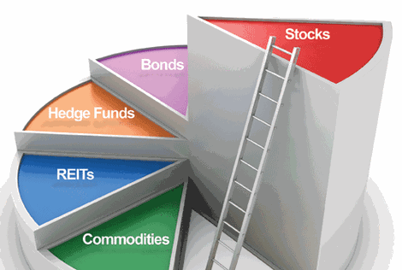

Many people think investing is a painful task. They imagine the entire process to be picking stocks individually and tracking of the performance constantly. Few even consider that they wouldn’t perform well without help from a financial adviser. If you research about the topic, then the process shouldn’t appear much complicated at all.

A smart investing strategy would be to keep an eye on the market trends and plan a move. You cannot link your future performance with your previous one. Just be sure of what you are doing instead of completely shying away from creating an investment portfolio. If done appropriately, you can set a smart passive income source for yourself which will support you for years to come and make your retirement period a phase of luxury living.

References:

- Forbes. 23 01 2016 <www.forbes.com/sites/mitchelltuchman/2014/02/14/investing-basics-building-a-portfolio/#33db1f734d04>.
- Lifehacker. 23 01 2016 <http://twocents.lifehacker.com/how-to-build-an-easy-beginner-set-and-forget-investm-1686878594>.
- Market Watch. 22 01 2016 <http://www.marketwatch.com/story/how-to-create-an-investment-portfolio-1304871610166>.
- Time. 23 01 2016 <http://time.com/money/3263186/diversifying-portfolio-5-rules/>.

