Chapter 4-Have an App built for iPhone or Android
Introduction
There lies immense potential in deriving money through selling mobile apps. Making money through apps is a popular passive income source. However, when it comes to app development there are several parameters that one needs to consider in order to be successful at the task undertaken. The first question that the developer faces is the decision making process while choosing app platforms.
There are several platforms including iPhone, iPad, laptop, desktop, Android, Windows device and more for which anybody can develop an app for. However, the most important thing is to choose a platform to begin with initially and then extend to other platforms. Getting started is the toughest thing to do and doing it right can make one successful in the venture.
It is quite challenging to have a quality app built that works immensely well on a platform. Complexity lies in extending to various other platforms. Initially it is better to start with a platform and then tweak the app to create a better user experience. Once the venture is successful it can be extended to other platforms when everything has been figured out. This will save a lot of your time and money.
Choosing between various platforms
When you intend to begin with app development, you would certainly be facing issues pertaining to platform development. The most popular platforms prevalent in the marketplace are Android and iOS. These two platforms account for more than 90% market share in the smartphone industry. The market share is dominated by Android and the profit share Apple. In addition, more loyalty is demonstrated by Apple users. The following key parameters can be considered while planning to choose the appropriate platform for your app development:
- Choose your market wisely
If you predominantly intend to develop an app for South American, African and Asian market, then Android platform can significantly benefit you. Apple’s reach is limited to customers that have very high income whereas Android is reachable to a wider audience.
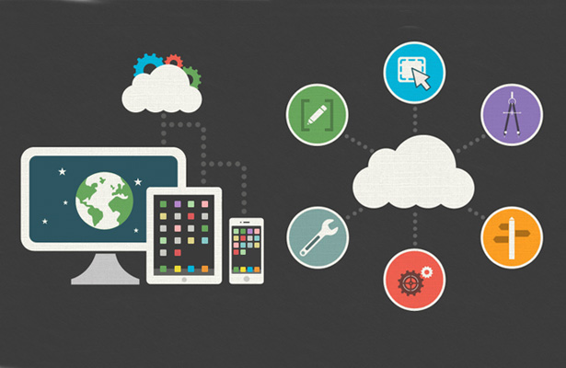

- Make money by charging for app directly or through in-app purchases
45% more revenue is generated by Apple through in-app purchases in comparison to Google. Moreover, iOS users indulge more in in-app purchases when compared to Android users.
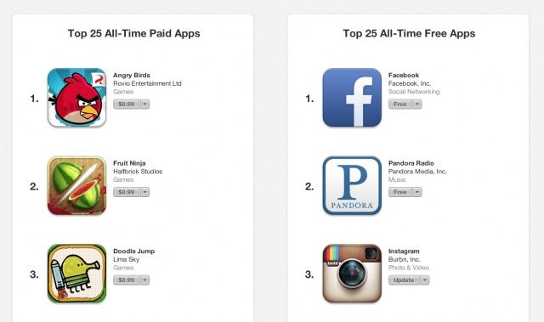

- Kind of app
If you intend to make a retail app, then choosing iOS platform can significantly benefit you. iPhone users more likely visit retail sites and indulge in purchases through their cell phone.
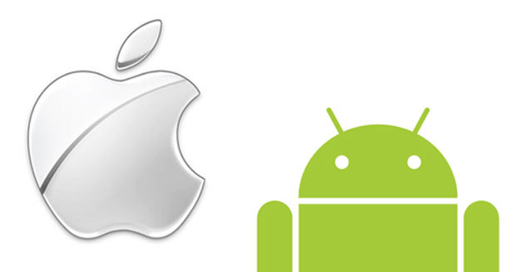
Both Apple and Android platforms have their own disadvantages and advantages. If you wish to reach a wider audience then you can consider developing an app for the Android platform. If you wish your audience is more loyal and engaged, then you need to go for iOS platform.
How to commence app building?
Once you have decided your platform, you need to consider how to proceed with app building. When you are planning to build an app, you need to consider the budget, the designing and the development phase. You can progress with your app development plan by considering the following ideas.
- Develop a prototype app
You can create the initial design of your app with the use of several tools that are available online. You don’t really have to write a code for the purpose. This process is referred to as the prototype or the mockup. There are several free tools available that can help with developing a prototype app.

- Develop a web prototype
Mobile app development can prove out to be quite expensive if you are planning to develop an app across various platforms. You can consider creating a single website where you have all the resources to test your concept first. This will help you in recognizing the core features that would be required within your app. Once you have decided clearly what you need to build, then you can save a considerable amount of money and time while developing the app across multiple platforms.

The technical considerations play a crucial role when it comes to developing a successful app. Now, let’s get down to the main agenda which is to generate money out of the app development process. A few years ago, the app development concept was relatively new. With the smartphone concept becoming more ubiquitous, the development of app has become a multi-billion dollar industry. This industry has become fragmented owing to the mobile apps nature. A lot of players in this industry have tasted success multiple times.

There lies unprecedented competition in the world of app development. Though there are several challenges, the opportunities in this area are quite massive. The subsequent paragraphs cover the many ways through which app developers can churn out money from their apps.

Charge per download

This may sound an unbelievably obvious plan to make money easily in a much easy way by charging the users for the download. It isn’t a secret that a lot of money can be made from download of apps. The app sales during the year 2013 reached $25billion. Apple has started offering app developers a sum of $10 billion as per recent reports. $15 million revenue per day was generated by Apple whereas $3.5 million was generated by Google Play during the year 2013.

It isn’t easy to convince the customers that they need to spend money on purchasing the app that you have developed as there are several apps in the market that are being offered for free. This process requires careful planning, execution and excellent marketing of the app.

Creation of an app that lies in-between free and paid category

You would have come across apps that are listed as free or paid in the app stores. There also exists a third category which lies in between in these two categories and is also a profitable one. There are several apps in the marketplace that are quite easy to download but require a small payment to be made in order to unlock the premium features, to turn off the ads and to progress within a game.

Candy Crush is a classic example of an app which is free to play but makes a lot of money by offering purchase options to the players within the game. To advance to higher levels, the players need to solve multiple levels. As the game proceeds, the difficulty level increases and hence the players need to purchase boosters in order to sustain in the game. You can learn significantly from the business models followed in similar apps to become successful in making money through the apps developed by you.

Advertising

Advertising is another technique through which apps can generate money by displaying advertisements to the users. Though the money generated is much lower in comparison to those generated through web placements, there a huge opportunity for the apps to make money by targeting the audience through this process.

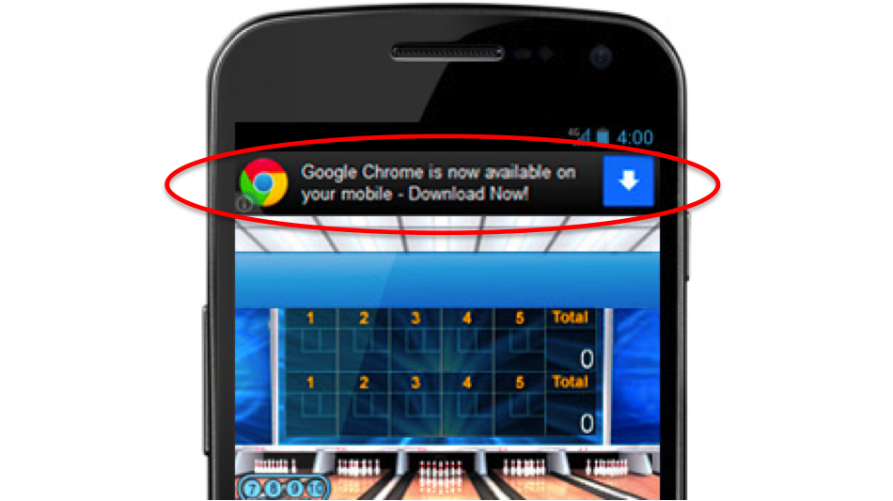

Look for sponsor

There are several non-game apps that do not fit well in the third category of lying between paid and free category. Such apps can benefit well through ad monetization. If you intend to offer your app for free, you still have the opportunity to make money by ensuring that your app users engage themselves in the ads.

One of the most profitable campaigns is by sponsoring the advertisers who wish their message to be displayed when the users are engaged with your application.

Develop a partnership with the mobile ad network

The most obvious manner in which you can money through your app is to include ads within your developed app. You can consider selling as space directly to the sponsors which is quite a lucrative way in which app makers can generate revenue. You can also partner with a mobile ad network that will charge you a portion of your revenue and will help sell your ad inventory.

Promotion Services

The chances are quite high that there would exist a correlation between the revenue you make through you app and the popularity of your app. Irrespective of the method you adopt in monetizing your app, more traffic is equated to more app downloads.

Your app would be limited to word of mouth promotion if you do not hire a company to back you with a marketing campaign. There are several companies that have hired leaders in the world of app promotions to get the required attention amongst the audience. These companies promote the app for a nominal fee. However, these companies are ensure that your app get a decent start on the charts.

Split testing tools

Throughout the app development process and marketing, the app developers make use of a feature referred to as the split testing. This feature lets the apps to figure out the optimal settings for their app.

Use of forums, free memberships and tools

There are several great paid and free resources that help the app developers and also the marketing companies. For assistance and ongoing support while involved in the app monetization process, the memberships and publications can prove out to be extremely helpful.

App Pricing

If you think the app that you have developed is quite good to be priced then you can take this decision wisely to work to your advantage. You need to come up with a price point where you can test various price points to benefit you.

Building an app is the first step anybody can take towards deriving profits. All your attempts of putting in a great concept together coupled with an execution done flawlessly would go in vain if you do not put in a marketing plan decently. Marketing plays a crucial role when it comes to selling your app and generating revenue from the app that you have developed. There are numerous strategies and channels that can be adopted for deriving money out of the app that you have developed.

Which route should your choose?

The app developers have to decide which path they wish to take when it comes to deriving money from their app development process. You can choose to build a paid app or offer a free app with immense following that you can generate a lot of money through the advertisements. You can also consider having a cross of free and paid app based on your planning.

Building a paid app

There are many developers in the marketplace who have chosen to offer paid apps. If you have developed the right app, then this strategy can work out in your favour. If you have managed to get a strong following and a strong brand, then this strategy is especially for you. Utilize it in a right manner so that it works out for you. This strategy can be applied to apps that are specifically business oriented or technical.

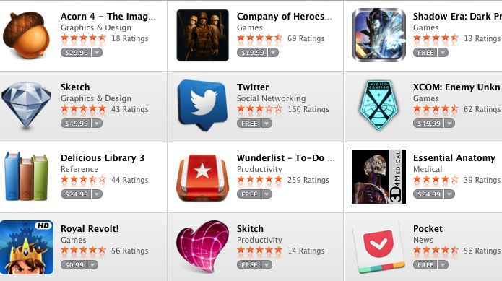

Building a free app with an excellent following

Free apps are ideal especially when you are just planning to enter into the world of mobile app development. It isn’t that this strategy wouldn’t fetch you anything right away. You can indirectly make money through your app by ad sponsoring technique. You can also try to develop a strong fan base by offering a wonderful app for free. You can later on plan to roll out a paid version of your apps when you have a decent following. Use this as an opportunity to flaunt your development skills initially. Your future sales are strongly dependent on the following that you gather when you initially venture into the market of mobile app development. Try to adhere to this strategy when you are new into Android app development.

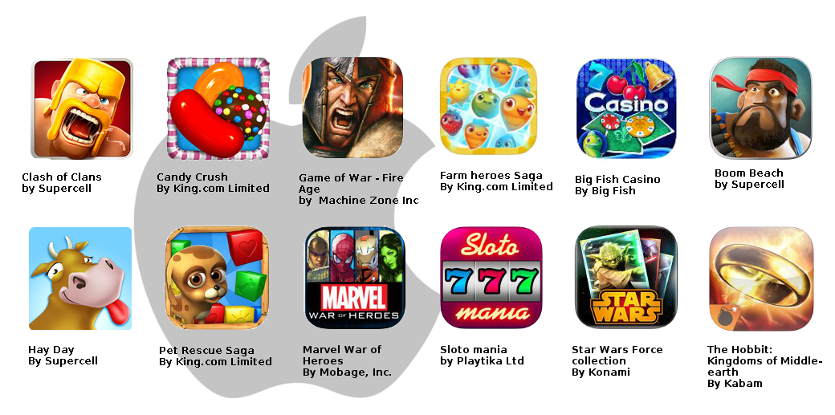

Build a cross of free and paid app

This strategy can work out greatly in favour of many game developers. This helps in gathering a following in the initial stage and the game popularity can lead to several downloads of the app. In the later stages, paid features can be rolled out. This works well because people get engaged with the app to an extent that they do not mind opting for the paid version to unlock several features. Candy Crush game is a classic example of such a game which can be downloaded for free but requires paying a nominal fee to unlock several features.

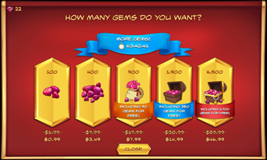

With tremendous increase in the competition in the app market over the recent years, it is quite challenging to create and launch an app that is profitable. However, though the industry is quite challenging, there isn’t any doubt about the world of opportunities that lies in the app development industry. Several attractive app monetization routes have been developed during the recent years. There is an ocean of free resources that is available which can make the entire process much easier. There is a plethora of pieces of the right advice and case studies available online which can be utilized to one’s advantage. You need to take advantage of every single resource available out there, if you wish to turn your idea into a profitable one.

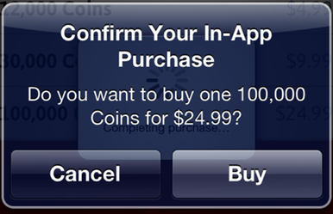
References:
- 19 01 2016 <https://crew.co/how-to-build-an-online-business/build-ios-app-or-android-app/>.
- Forbes. 19 01 2016 <http://www.forbes.com/sites/tristanlouis/2013/08/10/how-much-do-average-apps-make/#4d72180e12cb>.
- Hughes, Jeffrey. Android Apps Marketing: Secrets to Selling Your Android App. Indianapolis : Pearson Education Inc. , n.d.
- Monetize Pros. 19 01 2016 <http://monetizepros.com/features/101-ways-to-make-money-with-your-iphone-android-or-mobile-app/>.
- Smart Passive Income. 19 01 2016 <http://www.smartpassiveincome.com/5-things-you-must-know-about-creating-your-own-iphone-apps/>.
- zdnet. 19 01 2016 <http://www.zdnet.com/article/so-you-have-an-app-idea-and-want-to-make-a-bajillion-bucks/>.

