Chapter 3-Writing an eBook
Introduction
Whether you are nonfiction or a fiction writer, a complete novice or an experienced writer, you can always make money by writing eBooks. With the increase in the popularity of iPad and Kindle forums, eBooks have become immensely popular.
A wide range of opportunities has opened up for writers with the immense growth in the popularity of eBooks. Self publishing means have also provided the impetus to people who wish to have their book published.
Are you wondering what it takes to write an eBook and publish it online for generation of passive income? Do you want to know what it involves and the amount of money that you can make from writing eBooks? This chapter focuses on the factors that one must consider while writing an eBook along with the steps that one would have to follow in order to get their eBook published and to make money out of it.
How to begin?
The process of having an eBook getting published is relatively simple in comparison to writing down one. As many people are getting their books published with the option of self publishing, there are several issues associated with them such as poor editing, bad formatting and bad structure. People always rush when it comes to getting their eBooks published. This is where the problem lies. A badly written eBook would never sell no matter how cheap it is being offered.

This shouldn’t disappoint you. But there are very few writers who have achieved success by publishing their first eBook. Before getting down to create an eBook, you need to think about the topic you wish to write about. Do you wish to write a non-fiction or a fiction book? You need to decide on the niche if you are planning to come up with a non-fiction book. Guides and tutorials are ideal to begin with as people get to learn a lot from these. If you intend to write a fiction novel, you need to plan the genre you would want to focus on. Fantasy, chick-lit, paranormal romance and crime thrillers are immensely popular.

Before coming up with your own book, it is good to check out how other people create content for their books. Check out the top 20 best selling books which are based on the theme that you have chosen for your book. You would be able to figure out what would work and what wouldn’t.

The next thing to do is to decide on the length of the eBook. Most of the top selling eBooks offer quick reads and are short. These can be easily be read by people while commuting to work or to the university. After writing down the book, make sure that you proof read it to eliminate potential mistakes.

It would be a wise move to hire a professional editor to do the work for you. Nobody would want to read a book that is full of grammatical and spelling mistakes. This is undesirable when people are paying money for the eBooks. Once you are done with the content and the editing part, you can start designing your eBook cover. After all, it plays a key role in drawing attention of the people.
Never underestimate the potential of a book cover

A good eBook cover plays a key role in the success of the eBook. eBooks are always displayed online with a thumbnail that features the book cover design. Hence, it is crucial to have a good book cover. Make use of an image that is simple yet striking. It should be able to convey to the reader what the book is all about. If you are gifted when it comes to photography or graphic design, then you need to consider designing the cover for your eBook yourself. You can even hire a professional to do the task if you want your work to be noticed by a wider audience.

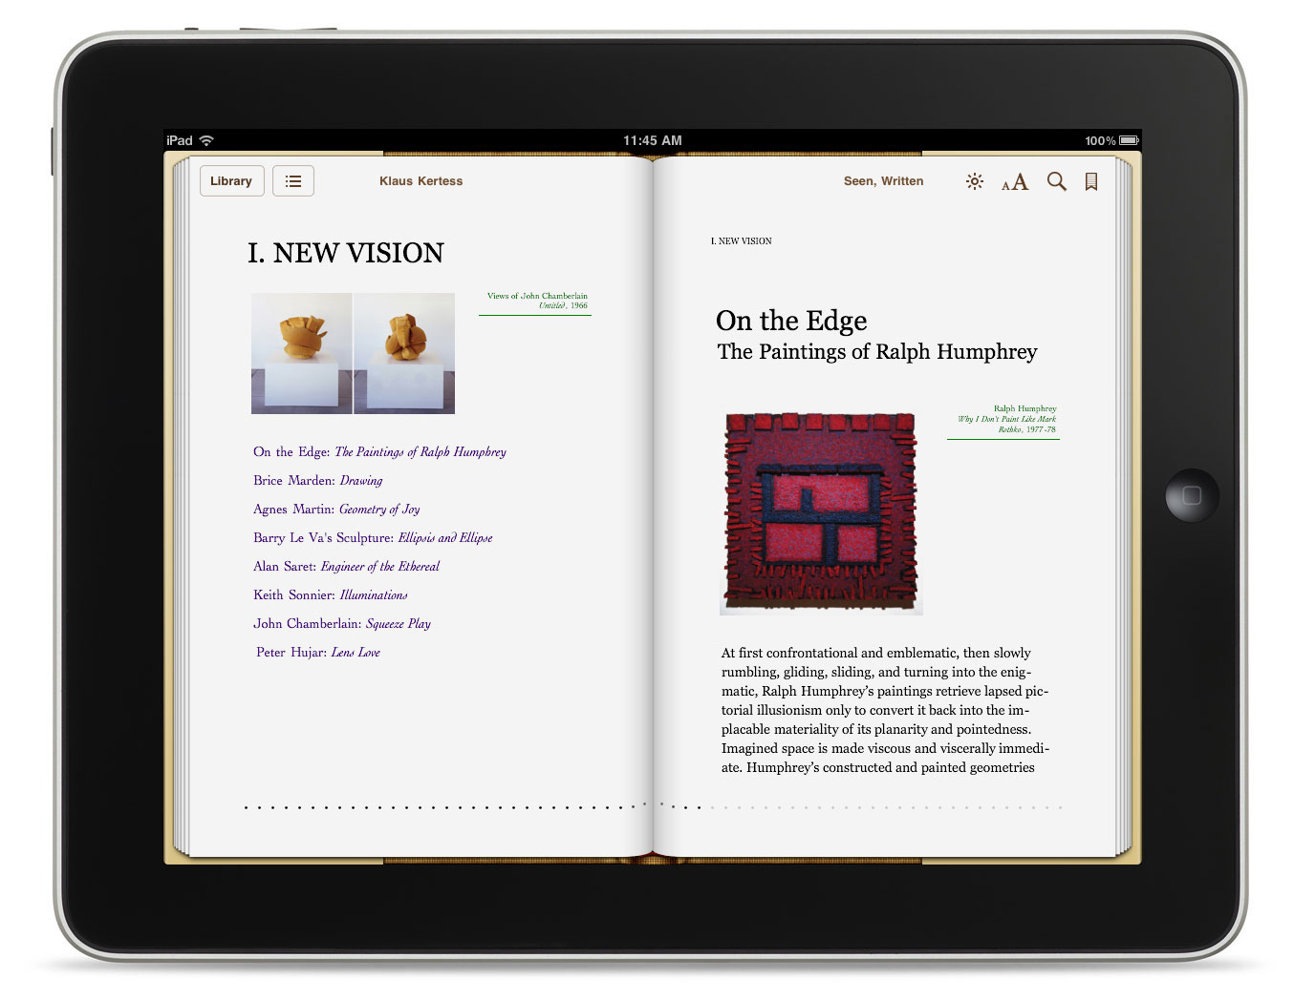

Uploading the eBook at an appropriate platform

Before you intend to have your eBook uploaded, you need to have a simple description of your work ready. Every platform has its own word limit for the description. This is where the potential of selling your work lies. Come up with a catchy, compelling description. Let people wonder what lies within the book and compel them to purchase your eBook with your description. You can also take a look at the site www.smashwords.com that allows you to have your eBook distributed on platforms such as Barnes & Noble, Diesel eBook store, Sony Reader Store and Apple iBookstore.

Pricing

Make sure that you have the price set as low as you can. The more accessible a book becomes to the readers when it is cheaper. If you are a first time writer, then you need to ensure that the price is really low.

Create a Brand

You always have to wait for a couple of hours or days to have your book listed once you save and publish it on online platforms. Having your book noticed by people is something that would take more time. It would be a great idea to have your book promoted on social networking sites such as Facebook, Google+ and Twitter. You can also have your own website for promoting your eBook.

First of all, you need to define the audience that you would be targeting. You need to figure out the people who would most likely purchase your eBook. You can also consider posting short blogs to grab the interest of the target audience. This would help with eBook promotions and also help you raise your profit margin. This would attract more and more people to your work.

Generating Revenue with Your eBook

Once you are done with the creation of an eBook that just seems great with an awesome cover and which has also been priced appropriately, marketed well and publicized effectively, you would then be wondering the possibilities of making profit. There are several writers who have made thousands and hundreds of dollars in a couple of months. The quality of your eBook plays a crucial part in this regard. If people love it, they would share this with more people and this is how your work would get recognition. More recognition implies more sales and hence amazing profit.

Factors to consider to make more money by selling eBooks

There are several factors that can tremendously impact the sales of an eBook. Here are a few things that you can consider while intending to make money out of eBooks.
- Adopt a targeted approach

The problem with most of the writers is that they do not define clearly what their eBooks must contain. This is crucial. A poorly structured eBook will never create waves in the marketplace. Add a little bit of targeted approach and scientific thought to bring about a dramatic improvement in the cash flow generation through your eBooks.
- Have small excerpts from the book republished

You can authorize web site owners and e-zine publishers to republish small excerpts or chunks of information that has been contained within your eBook. You can have your ad or your byline included.
- Sell monthly updates

You can derive extra profits if you roll out updates of your eBook monthly. You can also sell chapters of your eBook that were never released.
- You can as well consider giving your eBook for free initially and then offer the option of purchasing the paid version of the book.
- Offer the content of your eBook in reports. You can later offer people the option of making a purchase if they wish to grab the info contained within the book.
- Obtain the reprint rights of other eBooks and blend them with your work in order to offer a package deal.
- Place links in ad copies

Make sure you properly have the links of your eBook placed on networking sites. Whenever, people click on the link, they should be directed to the purchase page that may prompt them make a purchase.
- Offer half of the book for a cheap price

When you do this, people start reading the book. They will certainly make a full purchase for the complete version if they love the content of the eBook. Make sure to keep your book engaging so that people would be prompted to make a full purchase.
- Display a sample page to your audience

If you want people to be curious about making a purchase of your eBook then you need to implement this simple strategy of offering a sample page from your eBook and black out all the things that are important. This will certainly prompt them to make a purchase.

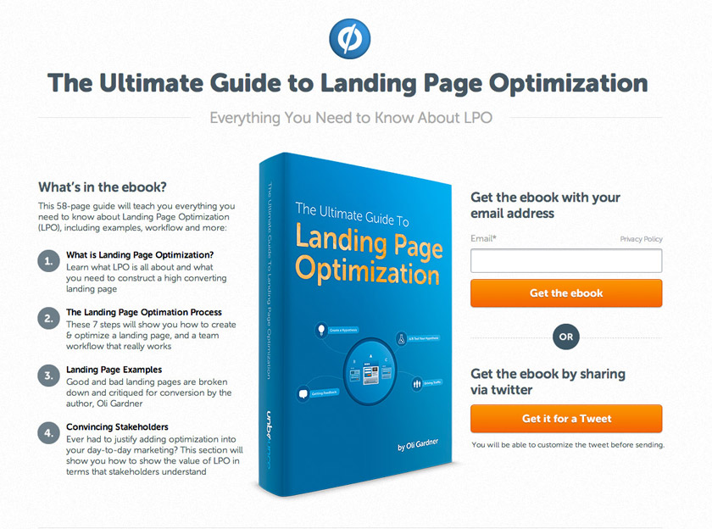
- Offer high and low priced versions of your eBook

Make sure you let people know the benefits of both the versions of the book. People are tempted to indulge more for being offered extra information.
- Make sure your offer reprint rights of your eBook

You can sell your eBook’s reprint rights. You can set a separate higher price for your reprint.
- Ensure that the book is available for offline reading

You can do this by offering an audio version of your eBook or by offering a print book.
- Have your book redesigned

When you have your eBook redesigned for a specific niche, you can derive a wide range of profits without having to do a lot of work.
- Offer discount coupons on purchases made

This is an ideal way to make more profits. People are tempted to make use of their discount coupons.
You must be having several questions in your mind while you are planning to sell your eBook for the first time. The subsequent paragraphs cover up the questions that you may be having in your mind.

Do I need to hire an agent?
You do not always need an agent in order to have your eBook published online. However, having an agent is a great thing. They can make your work a lot easier. They are aware of the right way in which you need to market your book and are also aware of the avenues with which more money can be generated out of your eBook which you wouldn’t even be aware of. They will have the deals negotiated for you in a professional manner and will ensure that your work get what it deserves.

What are the pros and cons of self publishing?

Here are few self publishing pros:

- You would be paid once in a month
- You get to control the cover and also the price
- Instant publication
- Changes can be easily implemented
- Excellent royalty rates
- You can easily do it
- You have the upper hand in taking decisions

What are the cons of opting for self publishing?

Here are a few cons of self publishing:

- No help in editing, formatting or developing the cover art for free
- Limited sales

Writing eBooks successfully and their strategic marketing can prove out to be a great source of passive income. You just need to do your initial research appropriately and churn out an excellent content that has been proofread by a professional and marketed appropriately. You will have to wait for a while for a response. But once, you have been noticed and established well, you would certainly be making a decent passive income from writing eBooks.

References:

- Disease called debt. 18 01 2016 <http://diseasecalleddebt.com/how-to-write-an-ebook/>.
- Online Income Teacher. 18 01 2016 <http://onlineincometeacher.com/money/how-to-make-money-by-writing-an-ebook/>.
- Project Life Mastery. 18 01 2016 <http://projectlifemastery.com/the-ultimate-guide-to-making-money-publishing-kindle-e-books/>.
- The Blog Press. 18 01 2016 <http://theblogpress.com/blog/make-money-online-with-ebooks/>.
- Wikihow. 18 01 2016 <http://www.wikihow.com/Make-Money-Selling-Your-Own-eBook>.

