Chapter 2- Creating an Online Course
Introduction
Generation of passive income sources requires one to put in a little bit of diligence. The generation doesn’t happen overnight. There are several passive income sources of which creation of an online course is also one. You must now be wondering what it would take to create an awesome online course that sells. You will have to put in some efforts for the purpose. Hours of audio, video, managing resources and much more would be needed to ensure that your online course sells. Never fret about the efforts that you need to put in for the purpose. The results would be awesome.
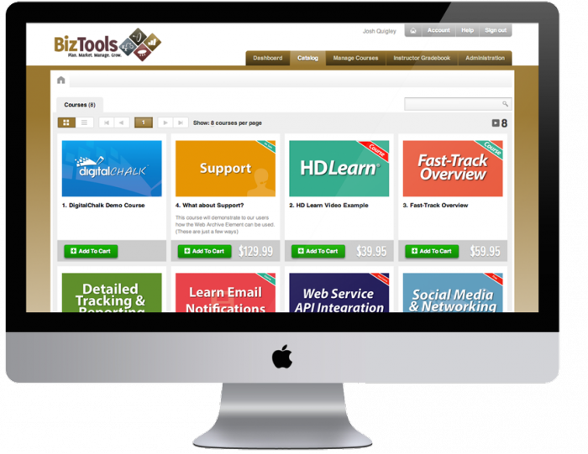
If you have a niche, there is no looking back. You can generate a smart passive income by building a comprehensive online course. You can implement smart strategies by structuring the course appropriately. Charge a monthly fee and then you can charge more for new resources, access to membership forums, updates and direct mentoring. You can have a recurring income by creating a successful online course.
Picking up a course topic requires a little bit of research. You can choose a topic which falls under your domain so that you face no hassles while handling the queries of the people who take up the course that you are offering. Do a little bit of research to figure out the courses that are in huge demand. You need to have an audience to come to you when you are offering a course.
Define a purpose for your course
Before starting with course creation you need to be clear about few things. You need to be clear about the purpose of the course that you would be offering. You need to pick up a profitable topic to teach that would generate money for you. Conduct a research on various platforms to figure out what people are looking for in a course. Content development and course creation should follow the research. You must be able to create audio, eBooks and worksheets out of the course that you develop. You must be in a position to promote your course online and market it appropriately.
Questions about online course creation
You must be having a lot of questions buzzing in your mind about online course creation and how exactly to drive money out of the course. The subsequent paragraphs cover up these questions your mind must be abuzz with.

How much would I make?
It depends entirely on the path that you choose. Your earning may be dependent on the course outcome. There are few instructors who make average but there are several who make a lot and also have a huge following on social media sites. These instructors have learnt the art of mobilizing their audience to purchase their course. A 6 figure passive income is sealed for such popular instructors. To reach that position, you need to begin somewhere.
How many hours do I need to put in to create a course?
Creating a course online isn’t an easy task. It requires one to invest time substantially. It may probably take the same amount of time one would require to write a book. If you already have a book in your hand, you can develop a course in fraction of the time required for writing the book. If you intend to gather the content on your own and don’t have an already developed resource such as a book for the course you are planning to teach, then you need to invest time accordingly.
Do I need to have special technical skills to develop a course?
Filming an online course and then editing it isn’t an easy task. Video editing is the most difficult aspect especially if you are planning to do it all yourself. You need to understand the right size in which a video must be shot, uploading it and fixing all the noise issues. You will have to make use of video editing and screen recording software for the purpose. Use softwares that are user friendly.
Which platform must I use to sell my course?

In this digital era, there are several ways in which one can publish their course online. You can utilize online academic forums that would offer you the right place to show off your skills. Here are few academics that offer the right platform to sell courses:
- Udemy
This academy has recently received amazing reviews from Forbes and NBC Today making it a place of high calibre to take up online courses. Anybody can create an online course at Udemy. Promotion of the online course can as well be done irrespective of the credentials.
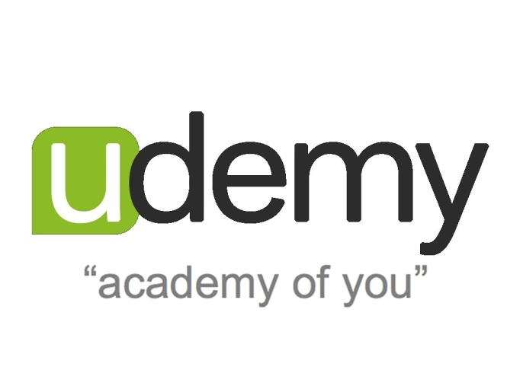
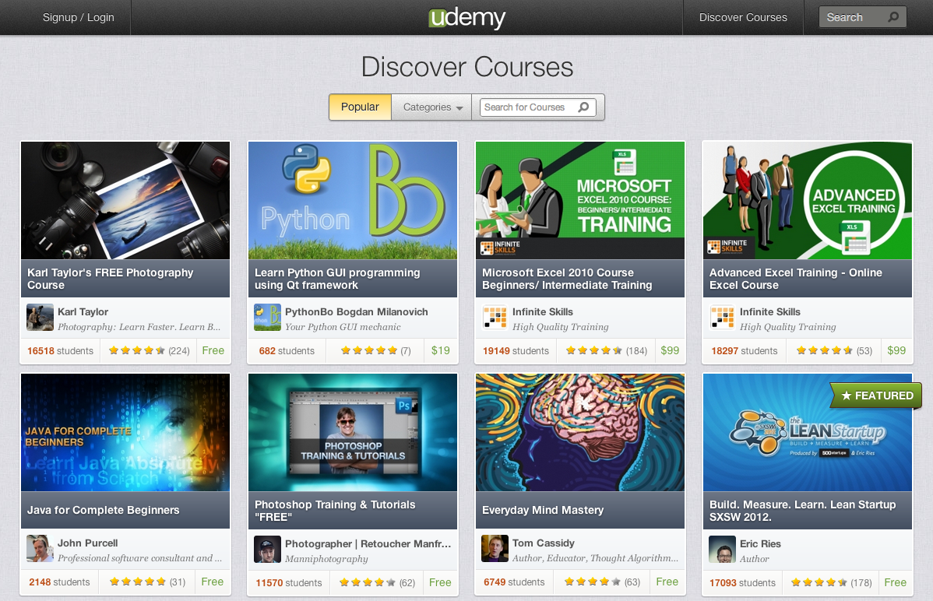

- Odijoo
This site is similar to Udemy and runs a platform that is open for anybody who is interested in offering courses for free or for a nominal fee. 10% of the revenue earned is charged by the site which is lesser in comparison to what Udemy charges. Udemy charges 30% of the revenue earned by the course developer. The best feature of Odijoo is that it lets you have personal campus where all the courses being taught by you are displayed. This lets you have your own education business online. You also have the liberty to syndicate your content thereby letting other tutors to purchase your course content and utilize them in their classes.

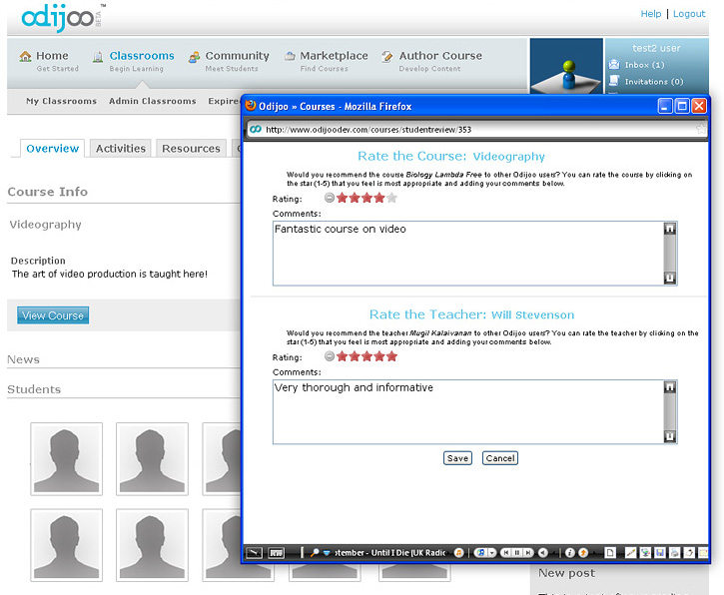

- Litmos
Litmos takes immense pride in being a learning management system [LMS]. It offers a user friendly platform for course creation and addition into the platform. A lot of perks are offered by this platform which includes branding, having a personal domain name and also a landing page. A fraction of revenue generated isn’t charged by Litmos. A minimum monthly charge needs to be paid by the member tutors.

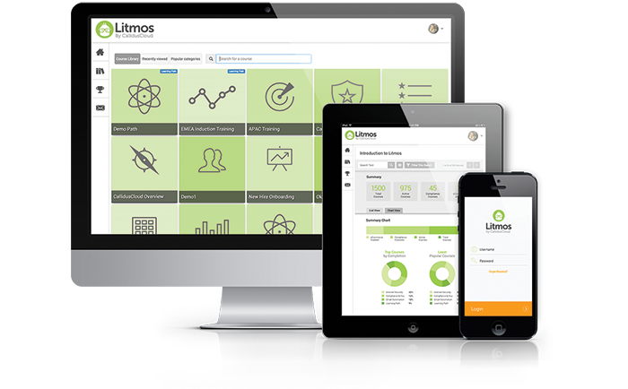

Create your own website

If you are quite serious about what you are doing, then you can as well consider having your own website. You can advertise the courses that you are offering by using email newsletter and through your website. This will let you retain all the profits and the additional money that you have earned by the sale of back-end products. You can also offer your students the chance to get direct email support from you. You can also offer additional materials such as eBooks to the students and also grant them access to the online forum by making them sign up for premium membership.

You don’t really need to develop a platform that is fancy. You just need to have a platform that would offer an informative and an effective online course. You can also offer lessons by sending out emails on a weekly basis.

What if I’m not able to answer a question?

Budding online instructors always have the fear of not being able to offer an on the spot answer to the queries raised by their students. This isn’t really a matter to bother about. You can deal with this situation maturely by telling the student that you would get back to her or him with an answer during the next session.

When you are a beginner, the best thing you can do is to avoid having live sessions initially. Gather some experience in the field you intend to teach the course and then go ahead with the live sessions. Make sure that you learn appropriately whatever you are teaching.
You also need to remember that you don’t have to know everything about the course that you are offering. You just need to ensure that you are a step ahead than the students you are teaching. To be on a safer side, you need to keep yourself updated with the recent news that is relevant to the topic. Keep a keyword of your topic and set Google Alerts that would be delivered right into to your mailbox. In this manner, you would be aware of the latest developments in the area of your expertise and this will also have your students impressed and engaged.

If others can do it, then you can as well!

You can draw some inspiration from people who make thousands of dollars from their passive income sources. Len Smith of England is a classic example who has been maintaining his copywriting online business from 30 years. He makes $120,000 per year from his online activities.

He realized the immense potential that creating online courses had and created a course despite while he was employed full time. He managed to juggle with the time and then decided to focus on courses entirely. He has developed courses on topics such as SEO, conducting presentations, copywriting and punctuations. When he started off, he was making around $4,000 per month. His income rose to $6,500 when he spent some time in marketing his new courses to his students.

Creation and selling of online courses have become Len Smith’s primary source of income. 30,000 students have taken his courses. He spends 30-40 hours per week when he is creating a course. Once the course goes online, he spends about 10 hours per week to market and maintain the course. His ninth course titled “Copywriting Secrets” fetched him $3,000 in a span of two days.

Professionals and students these days are looking for cost effective options such as online option instead of opting for traditional means of procuring higher education. As per Forbes, the online education industry would surpass $100 billion by the year 2016. A major fraction of this sum goes to the people who develop content for online courses.
Eliot Arntz and John Aziz made more than $ 1 million during the year 2014 for their course on app development on iOS 8. They owe their success to the combination of useful content, exceptional customer support and marketing efforts. They took three months on an average to create this course. They have hosted their course on their personal website and have structured their course as per the requirements of their students. You can get an idea of what it takes to create a course and sell it from these two examples. Get some idea, do some research and plunge into the world of creation of online courses.

Don’t forget to market your course!

The biggest mistake that people do when they create an online course is having the mentality that money would come to them on its own. This isn’t true. Whether you make use of a platform to host your course or post it on your own website, you need to indulge in marketing to make sure that enrolments follow.

You need to have an idea of your potential customers and must reach out to them. When you are planning to create your course, you also need to have a crude idea about how to make people know about your course. This tactic always works. You can also make sure that you give out exclusive offers to your audience so that they keep coming back.

The market for online courses is immensely huge. As per a survey conducted by Forbes, the market reached $57 billion during the year 2014. If the above mentioned information isn’t enough for you to jump into the world of creation of online courses, you can further read the tips mentioned below that would help you create and sell your courses online.

- It is a good thing if somebody has already created the course that you are interested in
You cannot sit around researching on topics that are unique and that has never been done before. This just implies one thing. No one would be interested in buying the course. If there is something that is needed and people are already paying dollars for the course, then that certainly implies the course has an established market. You can offer the same course but with a little bit of tweaking. You can consider offering the course at a competitive price, tweak the content and market it well. You need to consider adopting strategies that would make your course run. Competition is a good thing is you know how to how to compete.

- It’s OK if your first course doesn’t look great
When you are planning to create and sell your own courses online, you can look at people who have already done it and may feel a little bit dejected looking at the efforts they put in video editing and filming. You shouldn’t compare yourself to people who have already walked extra miles in the field you are just stepping into.

- Decide your course topic after doing some research
You need to first consider why people opt for online courses. The answer is quite simple. They do that because they have issues with the topic and intend to solve it. Maybe they are planning to get their hands on learning software that is quite complicated. Do a research on what people are looking for. You will certainly find loads of topics to consider for your first online course.

- People purchase courses even when the information is available for free

The sole reason why people opt for purchasing online courses is that they wouldn’t have to spend time on researching on the topic. Moreover, they do not wish to spend time on finding out whether the information being offered is legit or not. Opting for an online course seems to be a viable option as it would save them time and also the course would have been developed after hours of research. This is the reason why there has been an explosion in the online course industry.

Creation of online courses can prove out to be a wonderful passive income source if you are ready to invest some time for creating a structured course to sell online. Once the course is ready, you can spend time on marketing of the course to the targeted audience. You can go a long way in this field if you decide to take initial steps and work diligently to market your course. There lies immense potential for making money through selling courses online in an effective manner.

References:

- Business Insider . 17 01 2016 <http://www.businessinsider.in/How-This-Man-Makes-Up-To-8500-A-Month-Teaching-Online-Classes/articleshow/45622944.cms>.
- Forbes. 17 01 2016 <http://www.forbes.com/sites/dorieclark/2014/08/06/how-to-create-a-money-making-online-course/#2715e4857a0b3cf8e3964e3e>.
- Smart Passive Income. 17 01 2016 <http://www.smartpassiveincome.com/passive-income-101/>.
- Social Triggers. 17 01 2016 <http://socialtriggers.com/online-courses-create-and-sell/>.
- The Penny Hoarder. 17 01 2016 <http://www.thepennyhoarder.com/how-to-create-online-courses/>.

