Chapter One: Blogging combined with YouTubing
The world of the web has been strongly changed by the social media and the networking sites. YouTube has offered everybody a chance to present their views to a wide audience. One can easily reach out to the people with similar interests and share their views with others. YouTube has also become a source through which people can generate a passive income. YouTube has changed millions of lives by offering companies, 1,000 percent augmentation in sales. Boosting sales is also in a manner a way of making money through the use of the YouTube channel. This site has more than 200 million visitors who are unique every month from all over the world.
The use of YouTube can be a boon to bloggers and people who make use of the Word Press channel. There is immense potential to drive money from the YouTube platform and many bloggers are missing this out. When there are several of blogs over the web, why is the number of vlogs limited? Information, diverse content and real discussion that blogs offer can be produced in the video format as well. Blogs are limited to reading. But, vlogs cover the following learning styles: Kinesthetic, auditory and visual. With the use of videos in blogs, the audience that already exists on YouTube can be reached out easily.
Why vblogs on YouTube matter?
Ad networks and YouTube channels are stumping the worth of shows on television. The content creators of blogs cannot just limit themselves to blogging anymore. It is vital to reach out to a wider audience and interact with them in a manner that makes them connected to you. This can help you in a way to drive your passive income.
There are several reasons as to why people must consider developing videos for blogs. If you aren’t convinced with the idea, you must consider how individuals and media companies are utilizing YouTube.
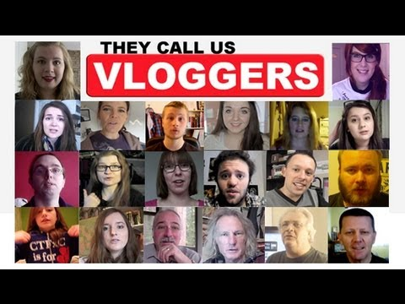
The trend of the content cross over
The first thing is that all the written media in the traditional format are now expanding their content by conversion to video format. You can check out the multiple channels of Mashable’s that run on YouTube such as the Mashable Originals and 5Facts. Popular magazines such as Vogue, Fortune, GQ and Vanity Fair have established their presence on YouTube. These have transformed their writing skills into an art of visual storytelling.
The trend isn’t unidirectional. Other platforms are trying to integrate YouTube features and YouTube is moving to the written and the print media. YouTube in short, has turned into a melting pot of content design. In this rapid progressing digital world, one can restrict themselves to one kind of media. Crossover is crucial to succeed.
Drive passive income with vlogs on YouTube
Did you know that you could increase your money making abilities by utilizing YouTube channel? Blogging can be made exceptionally productive for YouTubers with the use of sponsorships, promotions and advertising. Bloggers can make use of the effective and easy services of print on demand in order to create quality merchandise that the fans would prefer to buy. Blogging is a great source of revenue building when integrated with YouTube channel.
An insight into the blogging world
Blogs are short forms for weblogs or web logs. Initially, blogs began as personal diaries, which people retained on the internet. Now, they are much more than that. With the advent of Twitter, Instagram and Facebook, microblogging has had a great impact on personal blogging. Blogs aren’t limited to being personal notes anymore. Instead, these days, these are created having a specific industry in mind. These have taken up the form of guides, diaries and online magazines.
Being a YouTuber is an ideal opportunity to generate more revenue and grow a video brand. You can’t just drive a passive income out of any blog. You need to have a blog that draws more compliments from the YouTube channel than most of the blogs. You can include YouTube videos links and transcripts in your blog. This will ensure that all the content of your videos would be in a format that could be read by the search engines. This would imply that your blog would get more views and traffic. Videos integrated within blogs offer people an idea of what people can expect from a video if they can just watch it right away. A catchy content would have them coming back for more information.
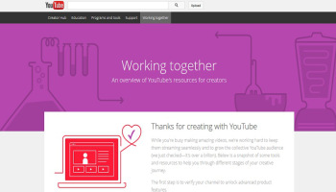
Inclusion of more content in the blog is recommended. This should be done more than the incorporation of simple transcripts. A companion blog can be created by enhancing the scope of your channel on YouTube. For instance, you could create and include a video per week on your channel if you have constraints pertaining to time and editing. You can as well post content, teasers, tips, relevant news, updates and behind the scenes pictures to increase anticipation and interest amongst the audience. These tips can be considered when you are lacking time and don’t have any additional material to be added to your YouTube channel.
Here are a few ways, employing which YouTubers can generate more revenue by running a companion blog.
- Utilize the feature of Google AdSense
The program by Google, which is referred to as the Google AdSense is a directed service for advertising placement. It utilizes the feature of keyword targeting and several other factors that help in placing ads on the YouTube channel or on the blogs that would interest the readers and the viewers. The banner ads are either image or text based. These are targeted specifically at the audience that enjoy the content offered. Whenever a person pays a visit to the blog and clicks on any ad that has been placed with a blog or on a YouTube channel, a commission is earned by the owner for offering advertisement space from Google.

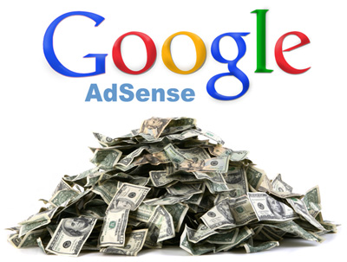

The more engaging your blog turns out to be, the more money you can make. You need to ensure that you do not encourage any kind of engagement or clicks with the use of ads in a manner that is against the AdSense TOS. This will result in your account being banned or flagged. AdSense isn’t the only feature with which one can make money by marketing or advertising for a blog or for any YouTube channel. One can also consider the option of direct advertising and affiliate marketing.

- Affiliate Marketing
Direct advertising and affiliate marketing seem to be quite similar but there are several key differences in them. You can utilize this medium to generate passive income for both your blog page.

Google AdSense only helps you in placement of ads that have a kind of relevance to the audience that you connect to. If you intend to generate money through the use of affiliate marketing, you have the choice to choose the companies with which you wish to have affiliation with. With affiliate marketing, you have complete control over the services and the products you wish to advertise on your blog page.

When you intend to choose a company you wish to partner with for any sort of ad campaign, you will have to place their banner ad within your blog page. Whenever a follower of your blog clicks on the banner ad placed on your blog, it makes use of the affiliate link to direct them to the official web page of the company.

When you opt for an affiliate marketing program, you will be offered a commission rate that is fixed whenever your blog audience makes a purchase of the services or the products of the company whose banner has been placed on your blog page. This will however offer you more control over the ad content that shows up on your blog page. You will make a better commission than what you would get through a couple of clicks on the ad links posted on your blog page.

- Direct Advertising
Direct advertising will help you seek out products, services and companies that can sponsor or advertise your blog page. This is quite tiring and time consuming. However, this is more profitable than other options of driving money out of your blogs. You will also have a complete control over what has been placed on your blog page just like in affiliate marketing. Payment is guaranteed in this method unlike AdSense or Affiliate Marketing.
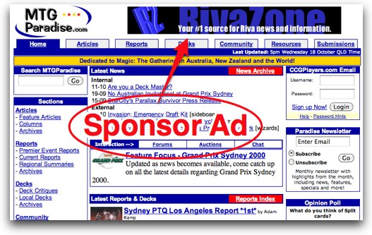

With direct advertisement, the companies you intend to partner with will offer you a decent sum to place their advertisements on your blog page. This can be done on the YouTube channel as well. You need to conduct product reviews of companies, mention everything in a positive light and also agree to adhere to the advertising contract. You just need to fulfill all the terms of the contract and the payment isn’t limited to clicks by your audience.

You will have to bear the responsibilities of managing all your sponsorships and advertising. You need to take charge of them and also need to keep them satisfied. You wouldn’t have to split your advertising money with the third parties. If you the time and the passion, you can figure out how direct advertising can prove out to be a lucrative passive income source when coupled with your blog and YouTube vlogs.

- Sponsored Reviews
You can get in touch with companies that sell products that are relevant to your kind of audience. For instance, if you run a beauty blog, you would write a product review or create a video review of a new beauty product that has just gained entry into the marketplace.

Many prospective customers always ensure that they check out the reviews of any product online. Especially, if the product is a new one. Beauty vlogs have become a trend these days and people follow it all the time before committing to the purchase of the products. This trend makes more and more companies partner eagerly with established bloggers who also have their YouTube channel. You can as well reach out to the companies that manufacture products which you would like to review for your blog audience.

Few companies also offer free products to bloggers so that they can use and review the products on their blog page and on their YouTube channel. The companies partner with blogs and YouTube channels in return for a high-quality, detailed review of their services or products.

- Clothing and Branded Merchandise
The creation of clothing and branded merchandise for YouTube channel and blog has become quite easier these days. Sites such as Speadshirt, Zazzle and CafePress allow the bloggers to upload their own designs for the creation of branded merchandise like posters, cell phone cases, mugs and T-shirts.

These services do no require the bloggers to make any kind of initial investment. They require the blogger to sign up for their services, upload designs, choose the product that needs to be created and sell them by the creation of an online store. Most of these online services offer codes that can be embedded within the blogs or within your website for promotion of your branded clothing and merchandise. They also allow for the creation of URL of the online shop that is easier to remember. This URL can be linked to the navigation menu and the blog posts. You can even take a screen shot of the products and upload them on your blog page with the link to navigate to the online store.

Most sites that offer print on demand services take care of all your merchandise orders and also manage the expenses occurred on the products by just deducting the expenses for the overall merchandise price.
Considering the fact that you made no investments, paying rent, the wages of the employees and any fees for inventory maintenance, this proves out to be a great way to drive revenue.

You can also consider having your own e-commerce site which you can connect to your blog platform and also promote on your YouTube channel. However, in this case you need to get the entire merchandise and clothing made yourself by finding a manufacturer or by bulk ordering. You would also have to take care of the entire distribution process which would drive more income for you.

You can boost the sales of your merchandise by posting all the relevant information about the products on your blog page. Embedding codes wouldn’t be tough to navigate to the product pages. You can also provide the link to your store on your blog page.

- Create blog posts that only add value
The main objective of your blog shouldn’t only be your passive income generation. Your audience would immediately sense your motive in such a case. Then they wouldn’t resort to clicking on ads and wouldn’t even purchase any of your merchandise. Your main objective must be to ensure that more and more readers or viewers visit your site and you need to offer them a valid reason for doing so.

You need to be consistent throughout and must be able to offer entertaining and informative content by placing proper links to your YouTube videos. By doing this, you will be able to create and maintain a blog that is successful. In addition, it will also be a fantastic companion to your channel on YouTube.

You shouldn’t forget to advertise your blog page on your YouTube channel. The more cross reference of the platforms and the linking on the social media platforms will enable you to get more visibility in the searches performed through search engines. You would be reachable to a wider audience and also you would be able to drive more income from your channel on YouTube and blog by diverting more traffic towards them.
Making money through blogs combined with YouTubing
Paid reviews and targeted advertising to your audience is a great way to drive revenue from your blogging activities. For this you must have a decent following. YouTube also offers a share in their revenue on their advertisements through its YouTube Partner Program. You can develop premium videos for training which can help people solve a complex problem easily. You can also charge people a small membership fee to make them join you, once you have a decent following.
What is involved to attain your target of deriving income through YouTube video coupled with blogging?
- Research on things you love and know
- Create and post videos on a regular basis
- Initiate a conversation and also reply to the comments
- Encourage your audience to share the videos that you have posted

YouTube is a great platform to share your videos and promote your blog as it is the second most visited site on the world of web. Vlogging on YouTube is catching a trend and many bloggers are generating huge revenue by doing so. Why shouldn’t you do it? The best thing is that YouTube is absolutely free to use. They even offer you money provided you enroll in their partnership program.
All you need to do is get involved in the creation of awesome videos and then work towards getting subscribers and views. You need to have little conversations with the audience in the comment section. This is crucial because YouTube will have your account reviewed before approving.
Becoming a YouTube partner shouldn’t be the end of everything. You shouldn’t just limit your revenue to the one that you are generate from ads. Look for other options as well. Clicks will certainly add to the revenue, but wouldn’t be your only source.
If you still aren’t clear about the concept of deriving passive income from blogging coupled with YouTubing, then you can try following the best bloggers within the industry you function. You need to keep in mind that the best channels on YouTube are the ones that get regular views from an audience that keeps coming back. You just need to create videos that are awesome and ensure that they keep coming back to your channel. Offer them videos that can benefit them greatly.
You can grow your audience and have a massive following by posting regular videos such as television series or funny videos. You can involve your friends and film nice videos every week. They need to be entertaining to prompt the viewers to share.
References:
- 14 01 2016 <http://www.yourteenbusiness.com/make-money-on-youtube.html>.
- Brad Schepp, ‎Debra Schepp. How to Make Money with YouTube: Earn Cash, Market Yourself. The McGraw Hill Companies, 2009. 1-8.
- Elegant Themes. 14 01 2016 <https://www.elegantthemes.com/blog/editorial/why-wordpress-ers-and-bloggers-need-to-youtube-more-often>.
- vlog nation . 14 01 2016 <http://www.vlognation.com/earn-m>.

