Chapter 9: Selling Stock Photography

Introduction

Are you looking for some extra cash? If you have the talent for capturing breathtaking digital photos, then you can certainly put them to some good use. You can pick out the best shots captured by you and can get money for trade them on micro stock websites. The term micro stock refers to the payments that websites receive from their customers for accessing their bank of images. A portion is offered to the photographer.

Amateurs and hobbyists can sell their photographs on popular portals such as shutterstock.com or istockphoto.com. Upon gaining approval from the micro stock sites, the photographers can start uploading their photographs and are charged a fraction from the sales.

Get started

In order to begin selling stock photographs, you need to ensure that you possess the appropriate equipment. You can sell your iPhone pictures on micro stock websites. It is vital for you to invest in a digital camera of good quality. Opt for a camera that offers you options in controlling the settings. You should be able to capture crisp images with your device.

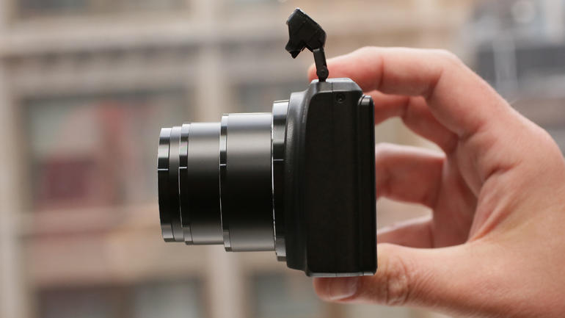

All the images that are submitted to microstock websites are inspected before gaining approval to be posted on the site. You need to learn all the technicalities of clicking a right picture in order to be a successful stock photograph seller. Big micro stock websites follow stringent rules before approving any photographer. Hence, it is vital to learn all the technical details of photography.

Create your portfolio

You need to be able to build a robust and diverse portfolio. You must be able to set a goal of photographs that you would be uploading on microstock websites on a monthly or annual basis. You need to consider the potential commercial uses your photographs can have. Make use of your connections and put them to good use. Offering nature or landscape pictures on a monthly basis can prove out to be bit hard. Hence, consider looking into the spheres of influence that you have easy access to.

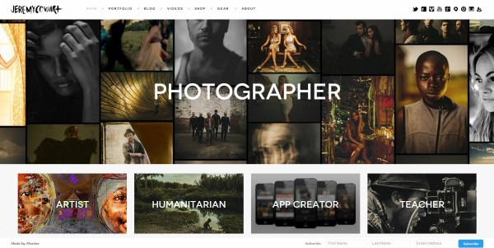

How much money can be made by selling stock photography?

You need to be really patient when you are just stepping into this field. An exclusive photographer on a popular microstock website would be making a dollar per photograph per month. The money made depends on the sales that have happened. For instance, if you are selling 1,000 photographs per month, you would be making 1,000 dollars or even more.

You need to understand that when you are just stepping into the field, you may not even be making a sale in a month or two. Your sales are dependent on several factors. You need to figure out the hot areas of stock photography to ensure that there are buyers for your images.

This doesn’t imply that it is hard to make money by selling stock photographs. There are several photographers out there who can make a decent living by just selling stock photographs. If you are in need for generating serious passive income through photography then you can as well consider wedding photography or advertising field in addition to stock photography. This would keep your spirit alive until you find a stable ground in the world of selling photographs.

How to really begin with selling stock photographs?

Once you have decided that you really wish to foray into the world of stock photography, you need to keep certain things in mind in order to successful in your venture.

- Be aware of your limitations and capabilities. You should be in a position to invest in quality digital camera and accessories that can help you click high quality images that can fetch you money. Image quality matters a lot when you are planning to sell stock photographs. The number one reason as to why many images get rejected by the editors is due to poor image quality.

- Visit the microstock website you intend to submit your photographs. Go through the images carefully and figure out where the void lies. Try to fill the gap. You would be able to find gaps in the topics that really need to be updated. You can also consider replicating a picture that has been outdated by bringing about a new twist.

- Go through the instructions offered by the microstock websites. Many websites offer detailed information about what is not needed and what is needed. All you need to do is follow it religiously in order to gain their approval.

- Develop your own style and try to refine it. Do not shy away from experimenting. You don’t really need to step into the trend game. You need to develop your unique style for which people would keep coming back to you.

- Learn how to interact with models if you are into fashion photography. You shouldn’t be uncomfortable in directing or communicating what you want. If you fail to communicate effectively, it will show in your final result and may disappoint you.

- If you wish to be successful in the world of stock photography, then you need to work diligently and keep refreshing your portfolio frequently. Many people take up photography as a full time profession and you need to keep up with them.

Is stock photography worth it?
If you go through photography blogs or read on forums online, you would find that there is a bit of negativity attached to the topic of stock photography. The negative comments come from photographers who have failed to make decent profits. This may make you wonder whether it is really a smart move to invest in stock photography any more. The truth is that you can make a full time profession out of selling stock photographs and doing more if you indulge in the activity appropriately. You need to figure out the right way of selling photographs and there wouldn’t be anything holding you back from generating a passive income for yourself.
You need to indulge in a little bit of research and figure out what works and what doesn’t work when it comes to selling stock photographs. The activity is worth your time if you know where you need to put in your efforts.
Here are few reasons as to why you shouldn’t shy away from foraying into the world of selling stock photographs:
- Just imagine. How many photographs do you have that are just occupying space on your hard disk without being noticed by anybody? Why not place them on microstock websites where they will gain the potential of making some money for you? You can upload the images on the sites and wait for the rewards coming in if done appropriately.
- Do you have images on photo galleries such as Flickr? You can upload these on microstock websites instead and make extra income.
- When you are new to the world of photography, you just don’t have to compare your profits with people who forayed into the world several years ago. You can make a decent amount of $500 a month if you have over thousand images posted on eight to ten top microstock agencies.
Stock photography tips
Selling stock photography is more of an art especially when the environment is quite competitive. Here are a few tips that will help you generate more money:
- Do not restrict yourself
Do not limit yourself to a single microstock agency. Make sure that you submit yout photographs to more than one microstock website. You shouldn’t restrict yourself to just one site. All these sites have a wide spread customer base and hence will help you to reach out to a wider audience. The chances are quite high that people would be utilizing the same keyword that they are using on a single microstock agency. Imagine the sales you can lose if you just limit yourself to a single microstock agency. The chances are even high that if a photograph isn’t accepted by one site, it may be approved by another site. You will soon figure out what works for one site and what doesn’t work for it.
- Rejected Images
There may be several reasons associated with why a particular agency rejected your photograph. Just because an image gets rejected doesn’t imply that it isn’t good. Several agencies offer an explanation as to why they didn’t approve of a particular image. You shouldn’t become disheartened or take it personally. When you enter into the world of photography, you need to learn how to deal with rejections.
- Consider resizing images
If you seriously have doubts about image sharpness, then you need to consider resizing your images. You need to make sure you resize it to the lowest resolution accepted by the microstock agency you are submitting it to. Never submit a full resolution image. Sharpness is enhanced when you minimize the file size.
- Check for noise in the photographs
You need to look for noise in the full size of photographs. Noise refers to the pixilated or grainy areas that are found on certain photographs. Images having noise are generally rejected by microstock agencies. In order to reduce the appearance of noise in your photographs, you need to consider changing the settings in your digital camera to the lowest ISO possible. Sometimes, you cannot control this owing to the lighting.
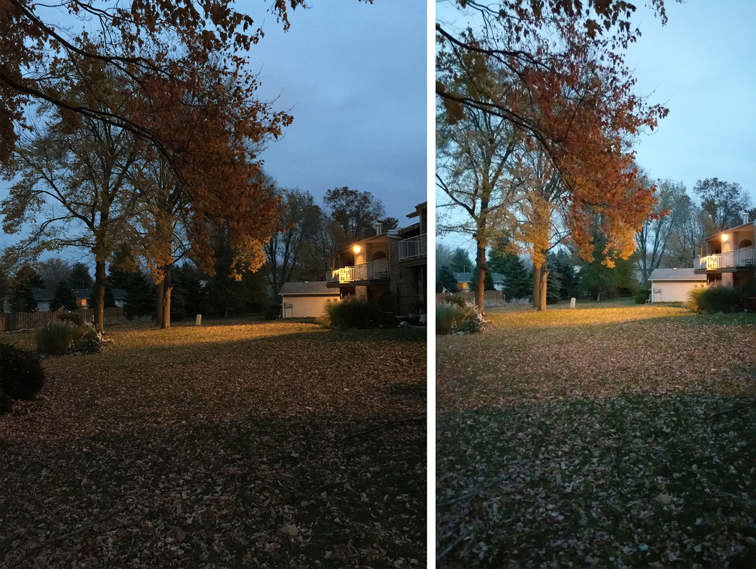
- Utilize photography tools
Once you enter the world of photography, you need to be in a position to make use of photography tools such as Photoshop to remove noise from the pictures that you have clicked. You can do this to prevent microstock websites from rejecting your photographs.
- Utilize the scientific name of flowers or insects
Whenever you submit a picture of a flower or an insect, you can consider using their scientific name when you add keywords. This can help you increase the sales of your picture.
- Be careful while cropping

Whenever you crop your images, make sure you don’t do it tight. Publishers who purchase images would want to utilize the pictures in full page advertising or posters. If you crop tightly there wouldn’t be any free space for incorporating quotes or words. Images that have appropriate space get easy acceptance from stock agencies in comparison to those that have been tightly cropped.

- Don’t stick to a single theme
Do not upload several photographs pertaining to the same theme on a microstock website as this may lead to the rejection of your images. For instance, if a particular agency approved an image of a high rise building that you have clicked doesn’t imply that it would want more of the same thing in various angles.

- Figure out what the agency is looking for
The chances are quite high that most of the agencies would have pictures of pets and roses. You need to consider offering them something that they do not have. Most of the agencies provide a list of what they want and what they do not want. You can consider going through it in order to avoid facing rejection.

- The more you submit, the more you make
You should always consider posting as many quality pictures as possible on the microstock websites. If you want to make a living out of stock photography then you need to set yourself a goal and offer as many quality pictures as possible.
Which are the best stock photography agencies?
There are several microstock agencies that have profited a lot within few years of coming into existence. Here is a list of few agencies that you can consider beginning your career with the reasons to do so explained.
- Dreamstime
This is the microstock agency that offers the highest royalties to the photographers per image. The amount varies based on the size of the photograph downloaded. The photographs get accepted quite easily and even the community of photographers is friendly. The images are accepted in JPG format. The size has to be a minimum of 3MP. The royalties are offered via Money booker, PayPal and bank check.

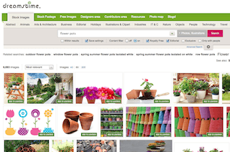

- Shutterstock
The payout offered by this microstock website is 25 cents for per sale of subscription downloads. This is one of the microstock website offering low royalties to the photographers. However, this site has a huge fan base. This is one of the most popular and largest microstock agencies. This implies that the sales of your images would be higher on this site.
Getting approval from Shutterstock can prove out to be quite difficult. You need to submit a 10 photographs out of which at least 7 need to be approved to get in. If that doesn’t happen, then you need to wait for a month to try again. The images are accepted in JPG format and the image size should be 4MP or larger.

- iStockphoto

This microstock website offers a fantastic manual explaining all the requirements and composition tips clearly. You must certainly try submitting your work on this site.

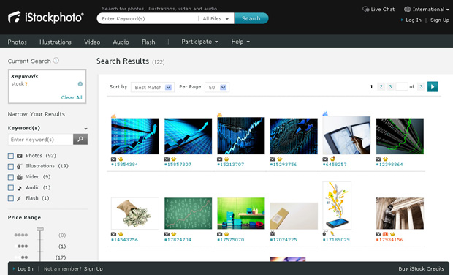

- BigStockPhoto

You can make anywhere from 50 cents to 5 dollars on your photograph on this website. You need to clear an online test in order to be approved by them. There isn’t any limit on taking the test. You can take is as many times needed. A high percentage of acceptances are offered by this agency, once you are in. Very few images are rejected by this agency and hence it is an ideal platform for beginners.

Selling stock photography is an ideal manner in which people with a talent for photography can make a decent passive income from. If you lack the skills, then you can consider brushing up your photography skills to venture into a field that is quite promising. Just do the right amount of research and you would be ready to foray into the world to start making money. You can even take up photography as a fulltime profession once you have set up a concrete base in this field.
References:
- cnet. 30 01 2016 <http://www.cnet.com/news/how-to-make-money-from-stock-photography/>.
- Improve Photography . 30 01 2016 <http://improvephotography.com/1129/how-much-money-can-you-earn-in-stock-photography/>.
- SLR Photography Guide. 30 01 2016 <http://www.slrphotographyguide.com/selling-stock-photography.shtml>.
- The Penny Hoarder . 30 01 2016 <http://www.thepennyhoarder.com/selling-stock-photography/>.

